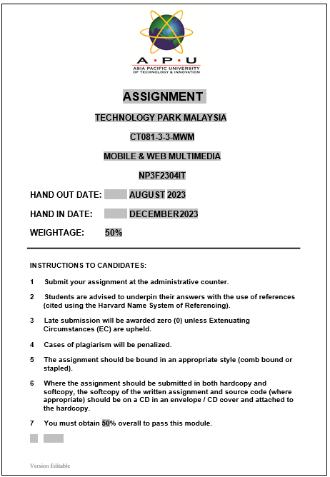

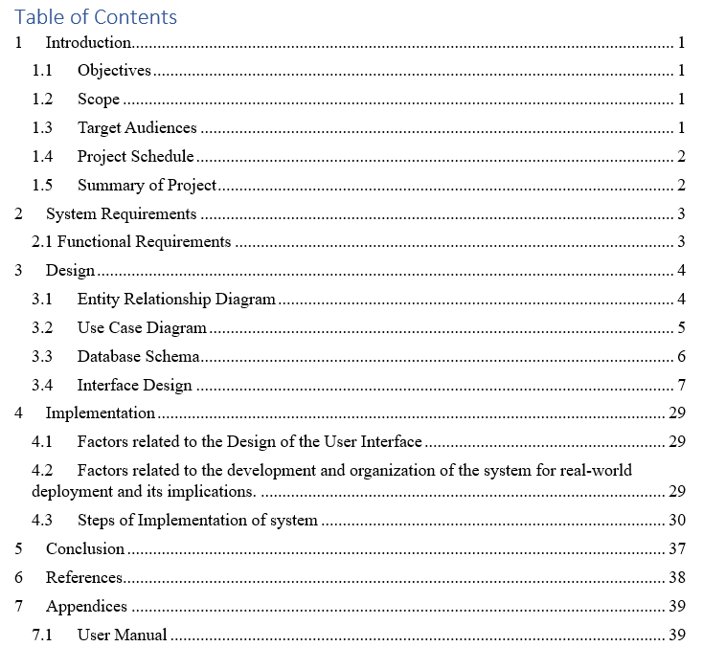

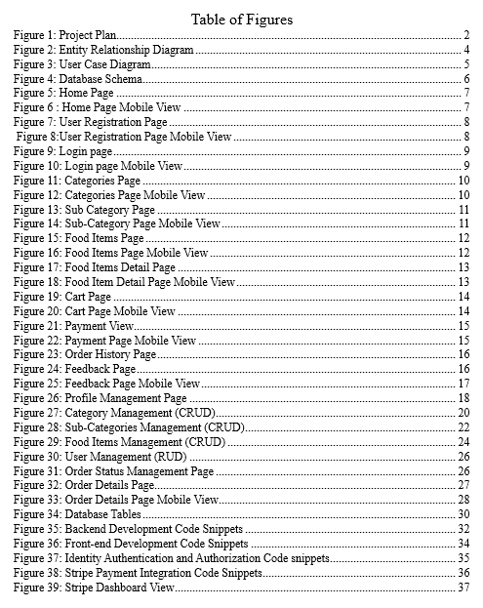

# Introduction

With the increasing development in the field of technology, all the related aspects have been positively affected by it. This has been a norm for society as it has positively awarded the people with a gift of online technology which has replaced the old method of having to visit the place for themselves. As in this modern society, people’s schedule is tighter than ever before which makes the physical purchasing method of food more time consuming and tedious. This has accelerated the creation of a cutting-edge online meal delivery system, providing a quick and effective replacement for conventional techniques.

A web-based project called Feast Flavor Online Food Delivery System aims to provide users with a smooth online ordering experience. With the admin interface, it enables restaurant employees to oversee and change the menu, guaranteeing that the food products and other information on the website are up to date. Likewise, clients may easily use the system for viewing a wide variety of available choices of delicacies on Feast Flavor with the help of online purchase.

C# programming has been used to create the web project's ASP.NET platform, which interfaces with the SQL Server database. SQL Server 2019 is used to make the database connection, and Visual Studio 2022 is used as the programming environment to create the web application. A solid and comprehensive framework for creating an effective and dynamic web-based solution is provided by this technological stack.

## Objectives

The following are some of the objectives behind the project which are listed below:

* To enable a user-friendly and smooth interface for online food ordering.
* To streamline all the processes involved in online food ordering.
* To enhance user engagement by making the system accessible for all.
* To monitor and optimize the system performance for efficient online food ordering.

## Scope

The main scope of the project is to give customers smooth ordering, monitoring, and menu-browsing experience. It has a strong feedback system, a variety of payment choices, and safe user verification.

## Target Audiences

The audience of this application is categorized into two sections which are:

1. Food Vendors
2. Food Consumers
3. General Public Browsers
4. Event organizers

## Project Schedule

The project aims to be completed with the implementation of the SDLC Model. This model helps to guide the project and complete the required tasks in the correct order for the successful completion of the project. The diagram below helps to show us the different tasks involved in the project model:

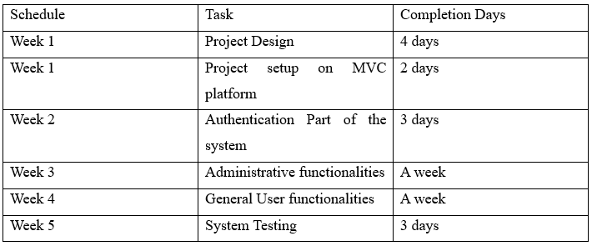

Figure 1: Project Plan

## Summary of Project

The project was completed in six weeks, with specific goals being met every week. Building registration and login pages for both admin and customers was the first week's priority. The following week was devoted to creating user interfaces for websites and making sure they operated without a hitch. The third week saw the development of the administration panel and improvements to the responsiveness of the website. In the sixth week of the project, the database was put into place, extensive testing was conducted, and any possible problems were troubleshooted and fixed.

# System Requirements

The system’s stakeholders require certain things to be delivered via the online food ordering system. These requirements clearly defines the purpose and primary objectives and goals of the system. Some of the requirements that need to be fulfilled are listed below:

## 2.1 Functional Requirements

**Member Registration**

**Login and Registration**

Users should be able to create a profile and login to the system with their email and password. This will also ensure the authentication part of the online food delivery system.

**Manage Profile**

Users should have a feature to view their profile details and edit certain information about their profile.

**Cart Functionality:**

An add to cart system will be added in the Feast Flavor so that users can view and add or remove items to their cart.

**Order History:**

The history of order will act as transaction and purchase history for the users to view their previous orders.

**Payment Support:**The users will be able to pay through certain services like cash on delivery o stripe when it comes to Feast Flavors.

**Customer Feedback Management:**

Users should be able to provide their valuable feedback on delivered orders and admins will be able to view it.

**Administrative Function**

**Manage User (RUD):**

Admins should have functionality to view, update and delete user accounts.

**Manage Products (CRUD):**

Admins will be allowed to add, view, update and delete food items.

**Manage Categories (CRUD)**

Admins will be able to add, view, update and delete certain categories.

**Order Management (CRUD)**

Order management is an integral part of this system as admins should be able to view and manage the status of orders as Pending, Processing, Shipped or Delivered.

# Design

This phase of the project includes all the structural designing part of the project where the flow of the data and other processes were design to assist in the development of project (Wiley, 2012). Certain techniques are used to generate the design of the Feast Flavor Online Food Delivery system which are provided below:

## Entity Relationship Diagram

ERD stands for Entity Relationship Diagram which refers to a structural diagram based on the entities in a database system. This shows the relationship among different entities involved in the system. The ERD helps to assist in the making of databases and establish a good relationship among different models of the system (Cagiltay, 2013).

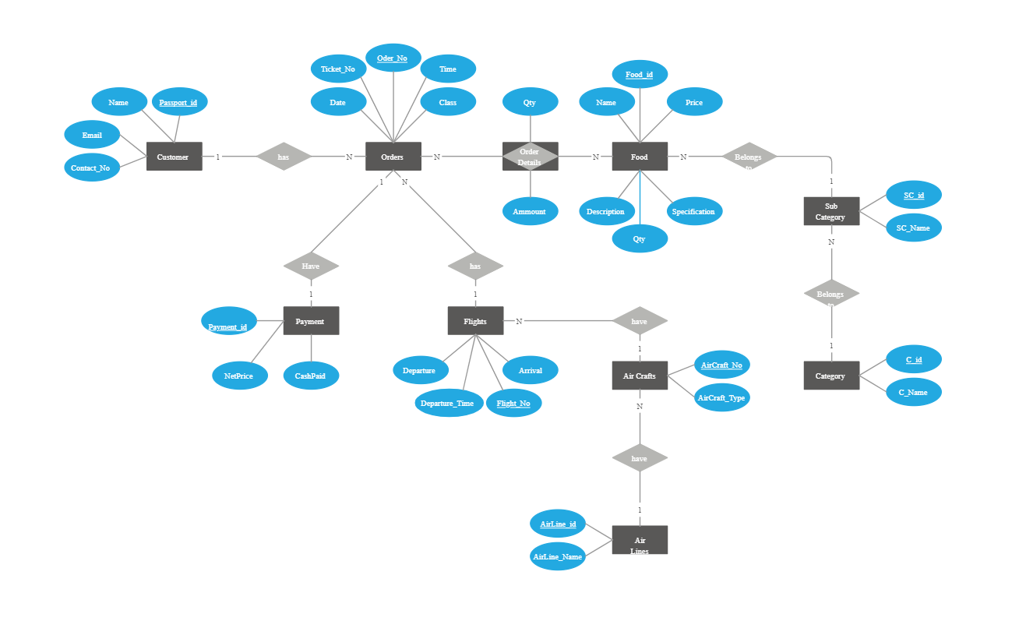

Figure 2: Entity Relationship Diagram

## Use Case Diagram

Use cased diagram is a graphical representation of functionalities a certain type of users can perform. Different events of the online food ordering system are represented and connected with the accessible users who can perform them. It shows the relation between different actors and activities available in the system (Parker, 2009).

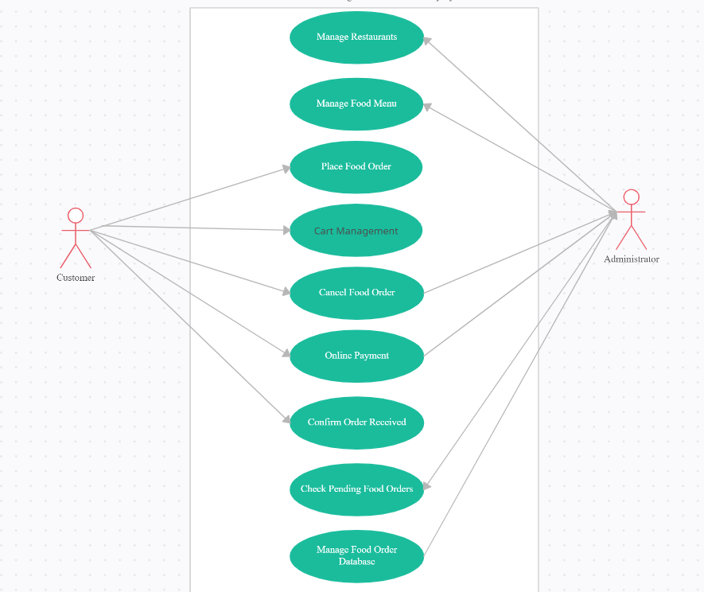

Figure 3: User Case Diagram

## Database Schema

It refers to a blueprint or the ground level structure that defines the organization of data in the database system. The database schema shows the local organization of different tables and fields along with the constraints in the table which maps the relationship between different tables in the database (Cleve, 2015). Here, below a database schema related to Feast Flavor Online Delivery System is shown:

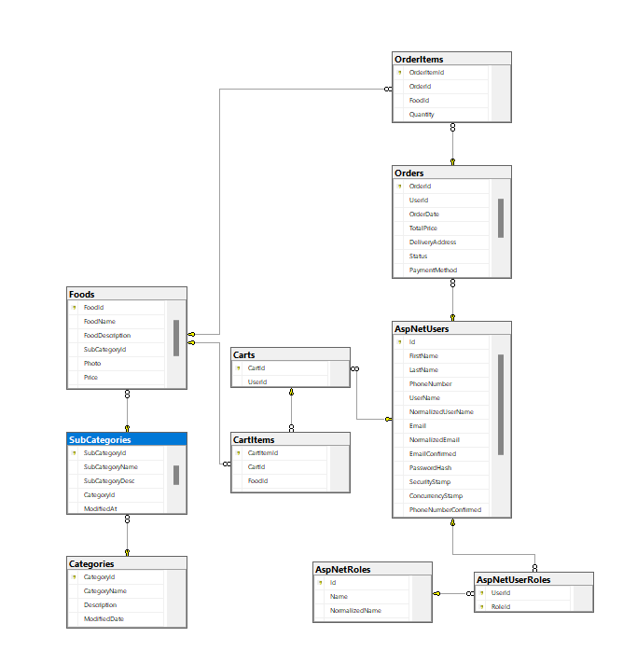

Figure 4: Database Schema

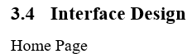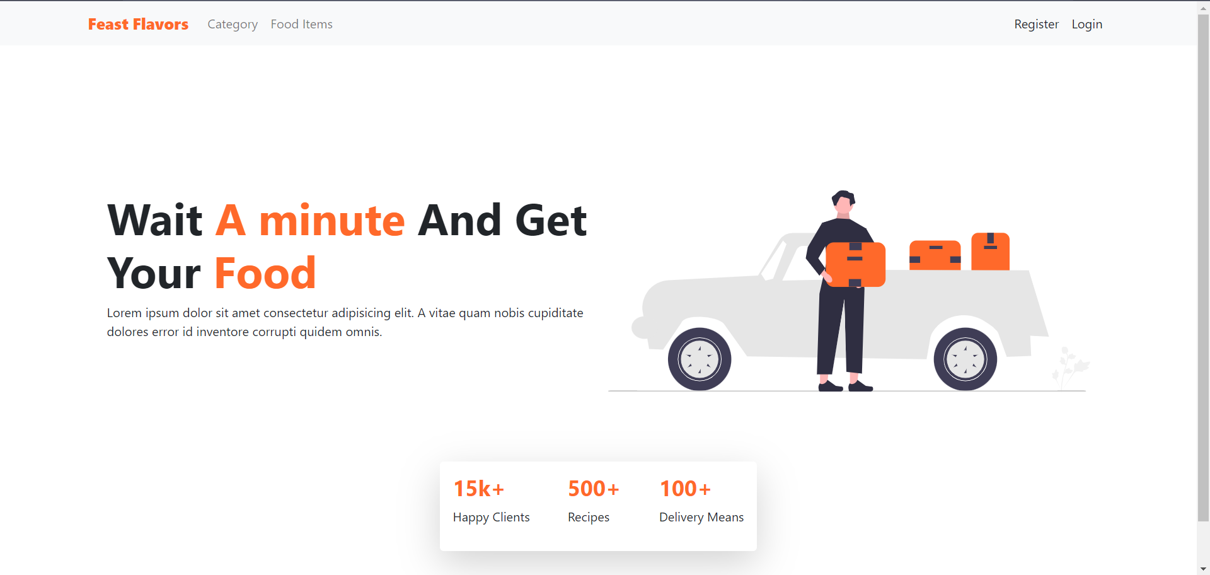

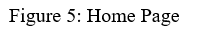

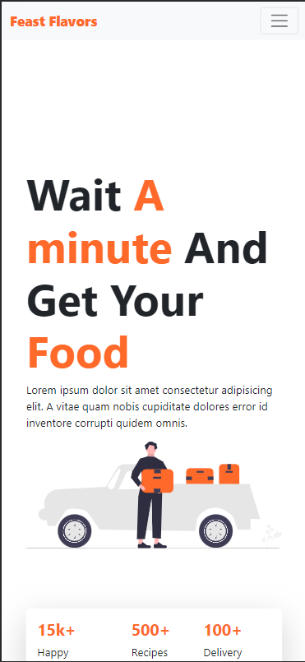



A minimal home page where certain instructions related to the online food delivery system is provided. The styling is more focused on modern and minimal styling techniques.



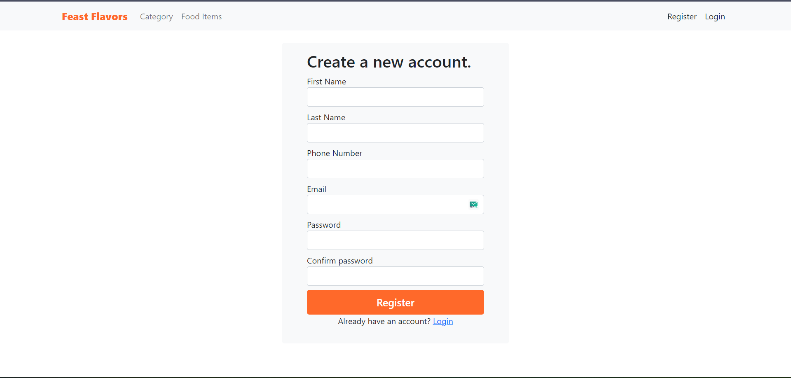



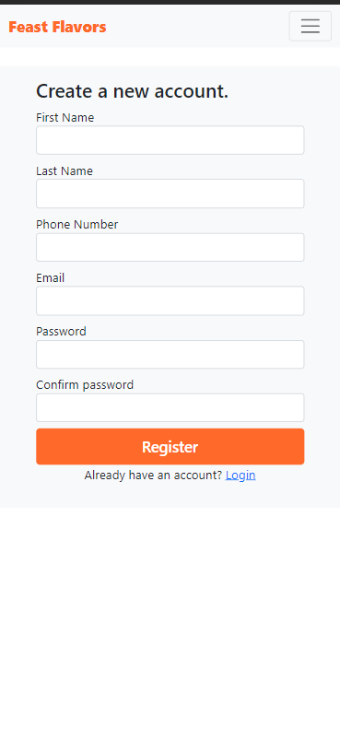  
Figure 8:User Registration Page Mobile View

A simple registration page for users to fill up their personal details and register into the system.

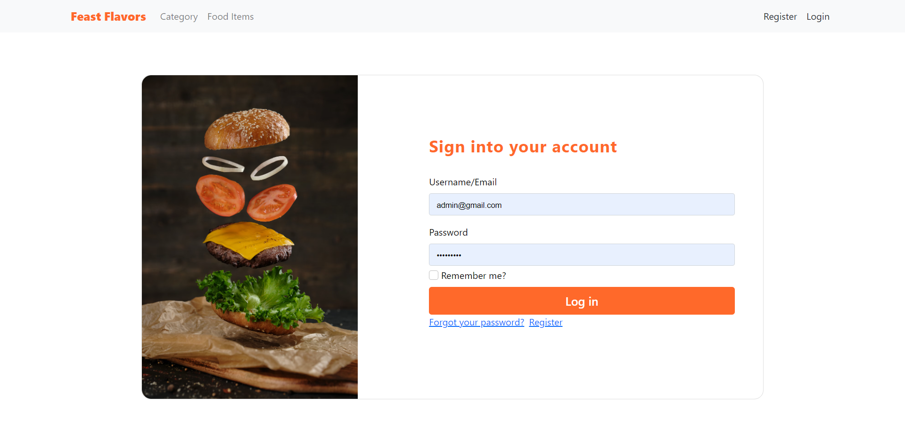

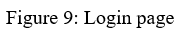

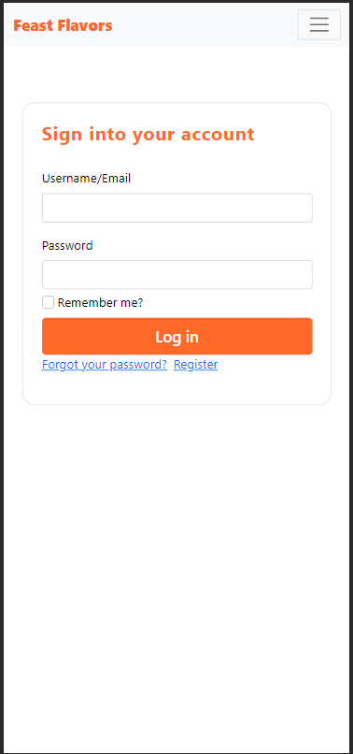

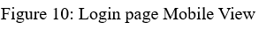

A minimal login page with the use of bootstrap cards and performs along with all the validations in input for Admin and General User to login to the system.

User Categories View

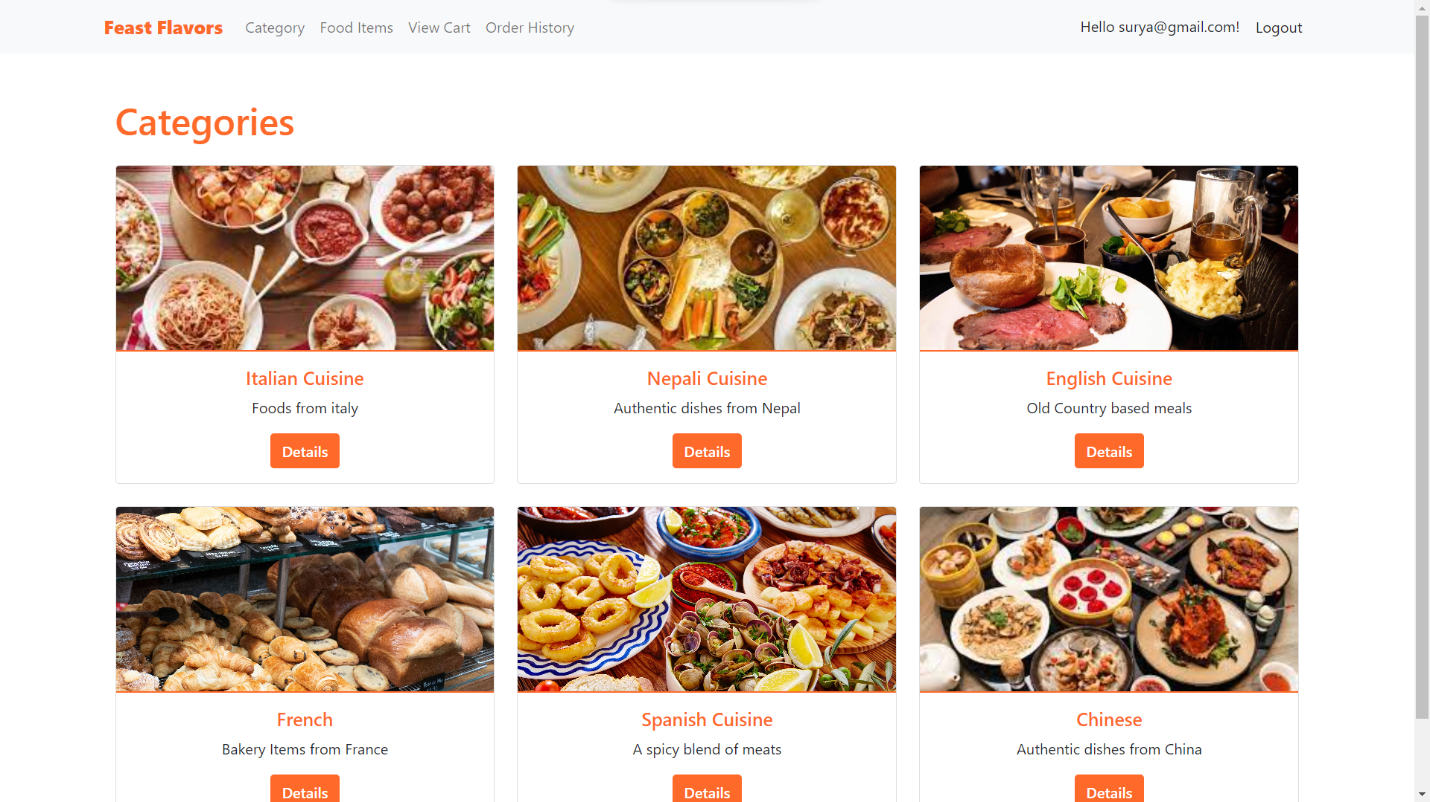

Figure 11: Categories Page

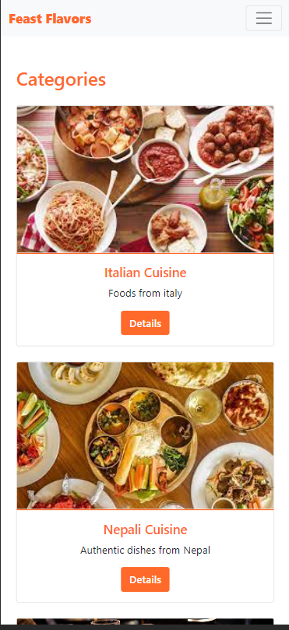

Figure 12: Categories Page Mobile View

A view of categories available in the system where user can browse through different cuisines and view details of the cuisines.

Sub-Category View

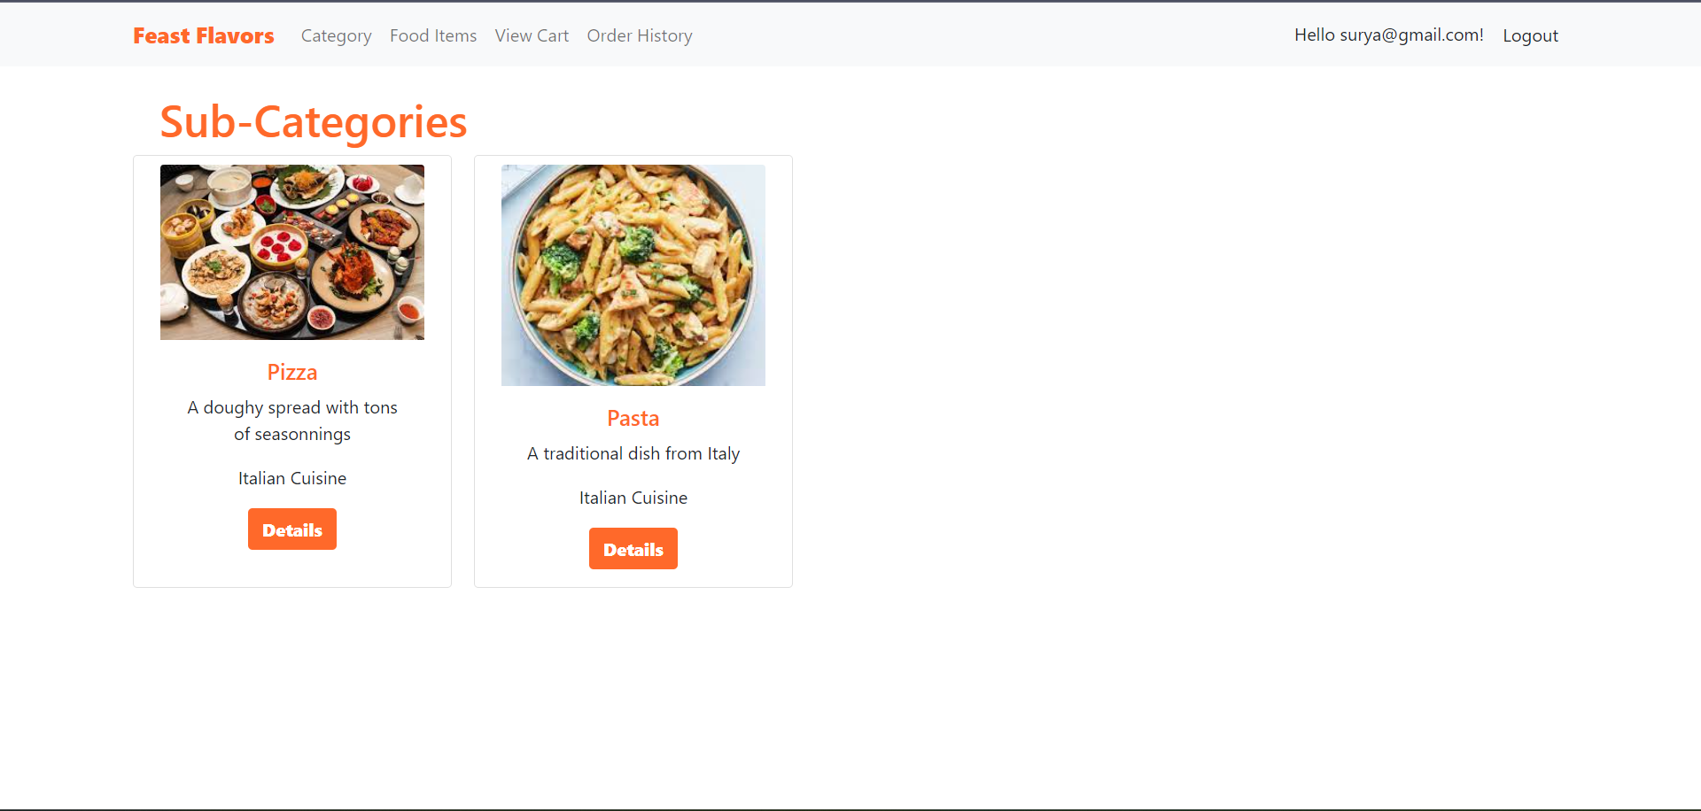

Figure 13: Sub Category Page

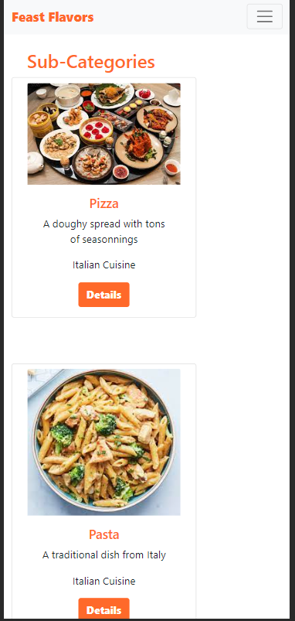

Figure 14: Sub-Category Page Mobile View

A detailed view page of categories which consist of the sub categories inside the selected categories. A simple card view is chosen for minimal look and feel in order to make the pages more user friendly.

Food Items View

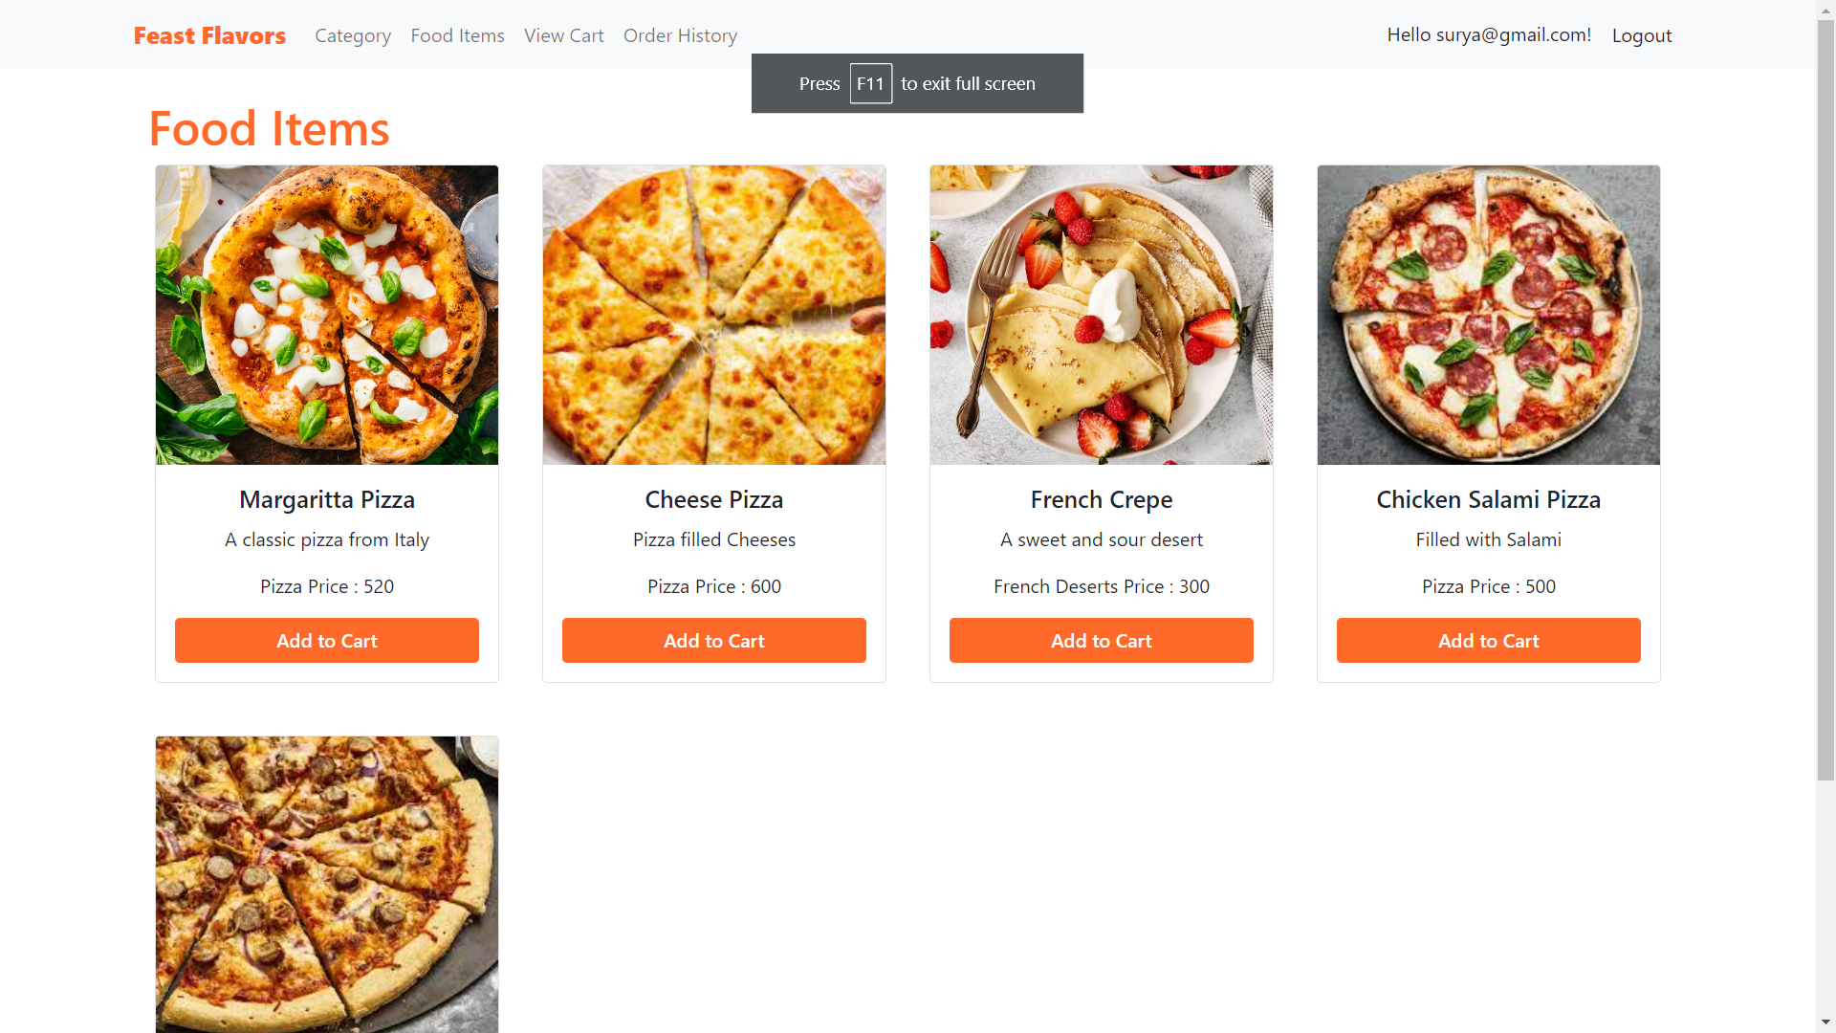

Figure 15: Food Items Page

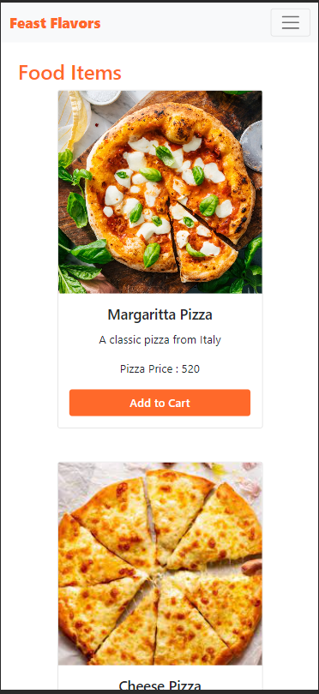

Figure 16: Food Items Page Mobile View

A general view of food items available in the system where users will be able to add certain items to the cart.

Food Item Detail Page

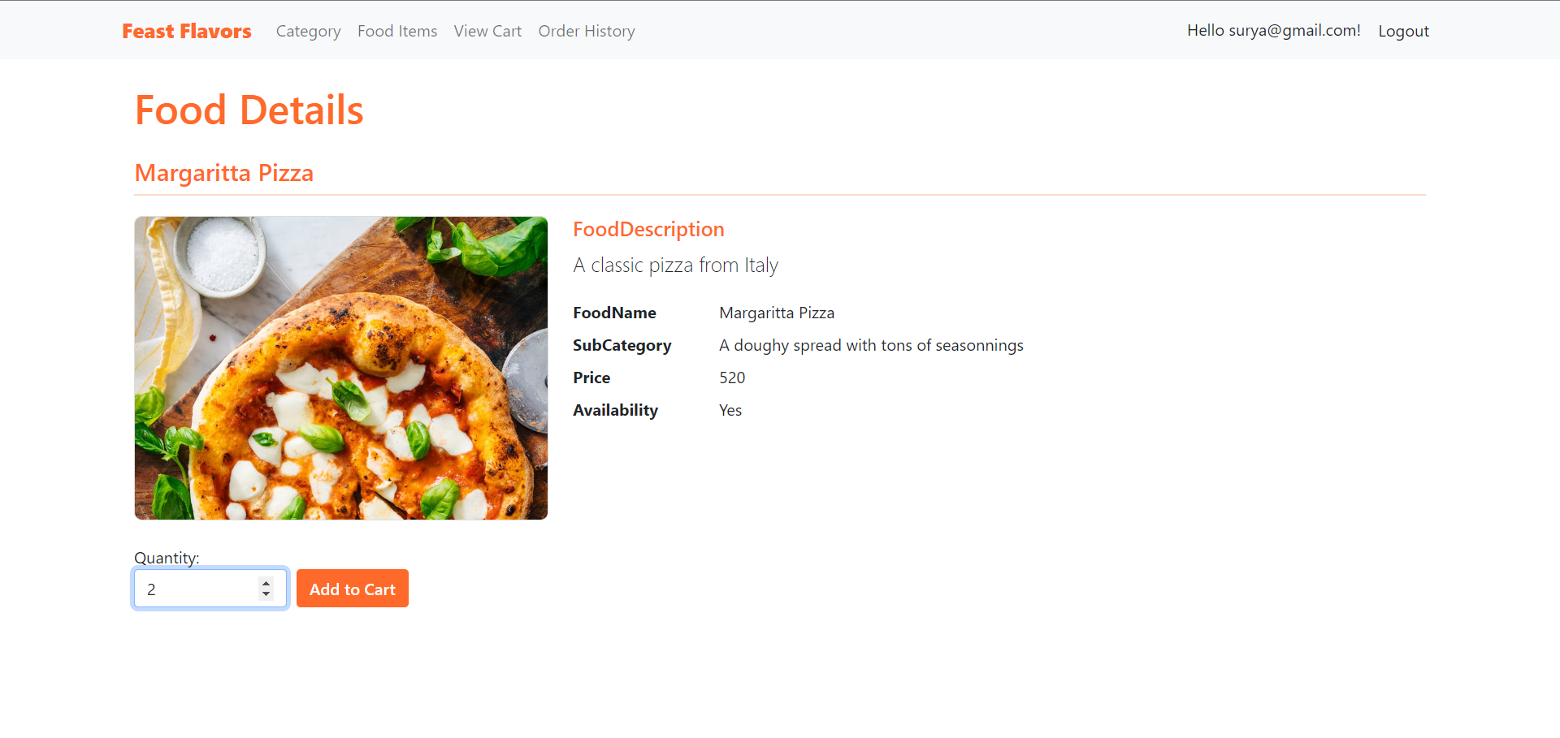

Figure 17: Food Items Detail Page

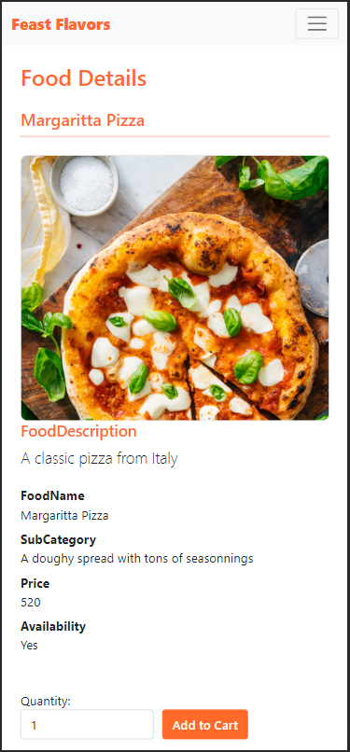

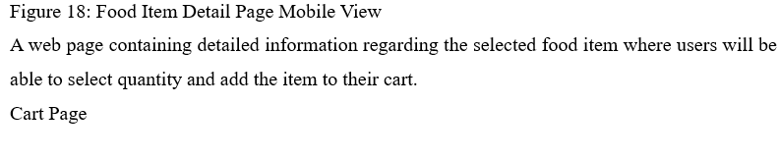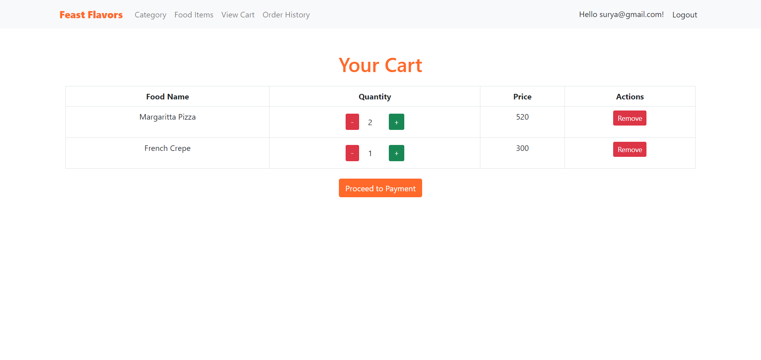

Figure 19: Cart Page

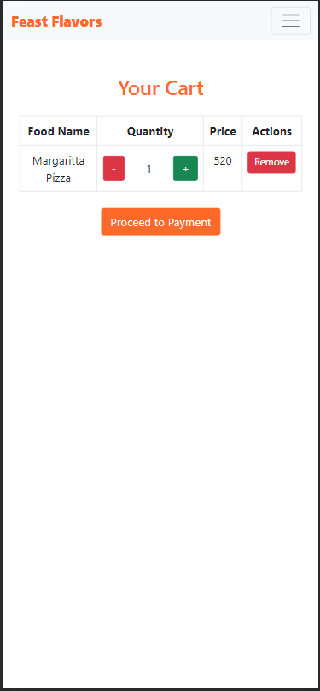

Figure 20: Cart Page Mobile View

This is a simple cart page where users will be able to add or remove items in the cart. The functionality of increasing or decreasing the quantity of items is also providing here.

Payment Page

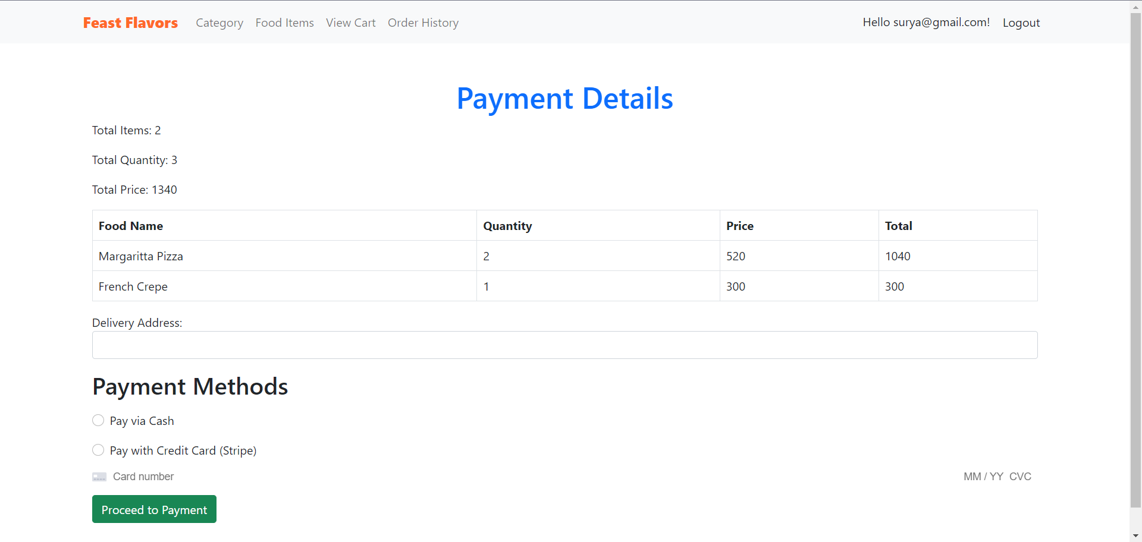

Figure 21: Payment View

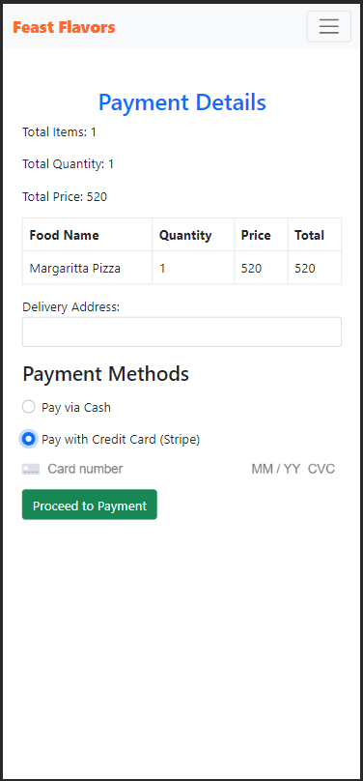

Figure 22: Payment Page Mobile View

This is the payment view page from where user can view the transaction related information where use will be able to add delivery address and add payment method. Here, payment option with Stripe API has been integrated to show the payment method.

Order History Page

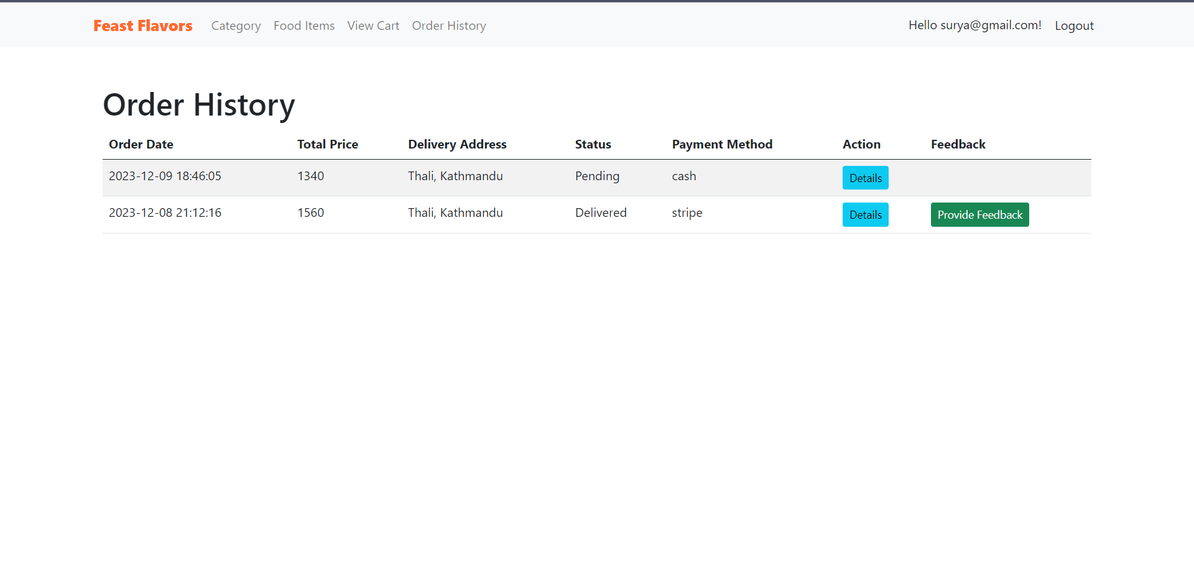

Figure 23: Order History Page

This is a order history page that contains details regarding the orders of the specific user. Users will be able to check the status of their order ma view details of the order.

Feedback Page

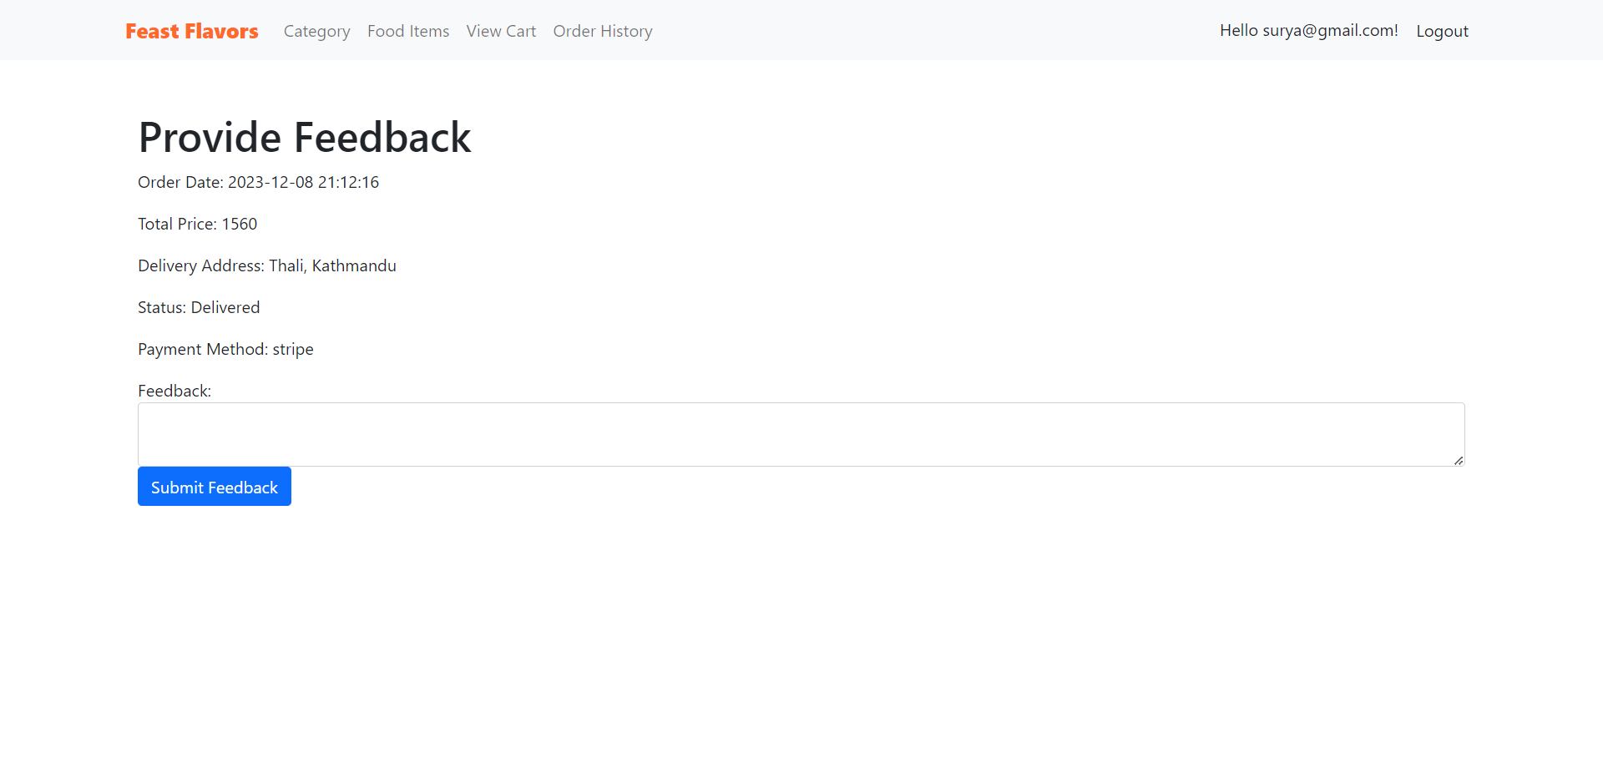

Figure 24: Feedback Page

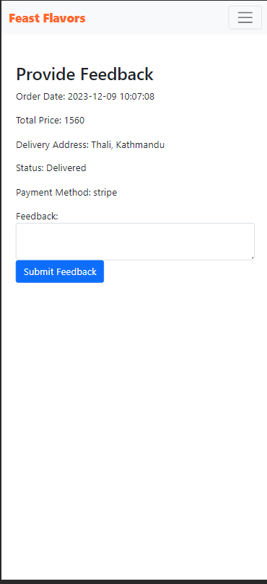

Figure 25: Feedback Page Mobile View

It is a simple page with a input field to provide feedback to the admins on specific orders.

User Profile Management

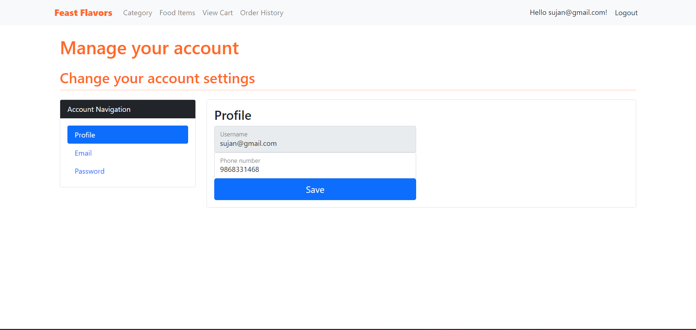

Figure 26: Profile Management Page

Through this page, users can edit or update information regarding their account.

Admin View

Categories Management (CRUD)

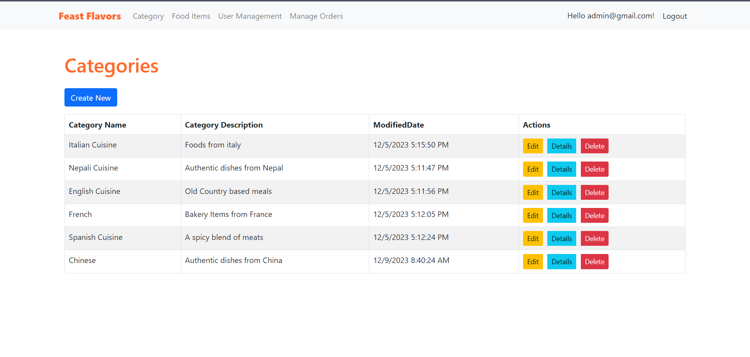

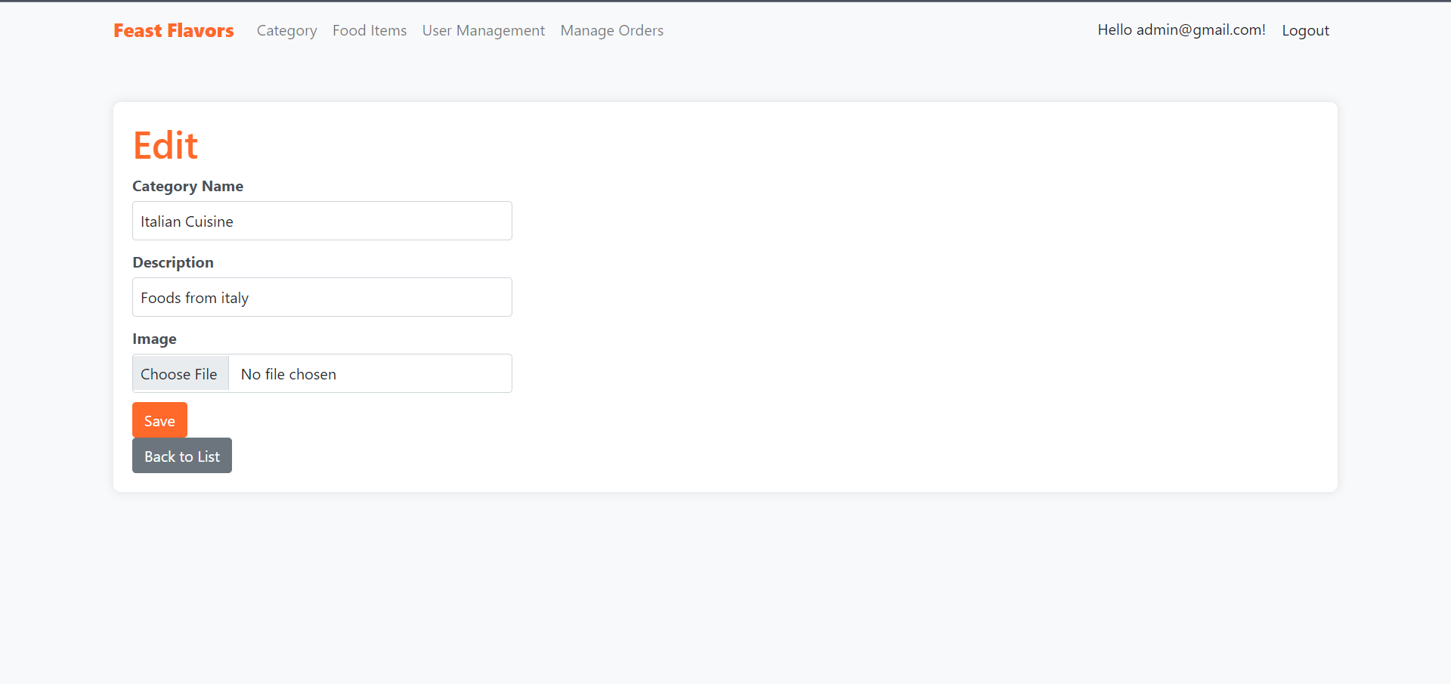 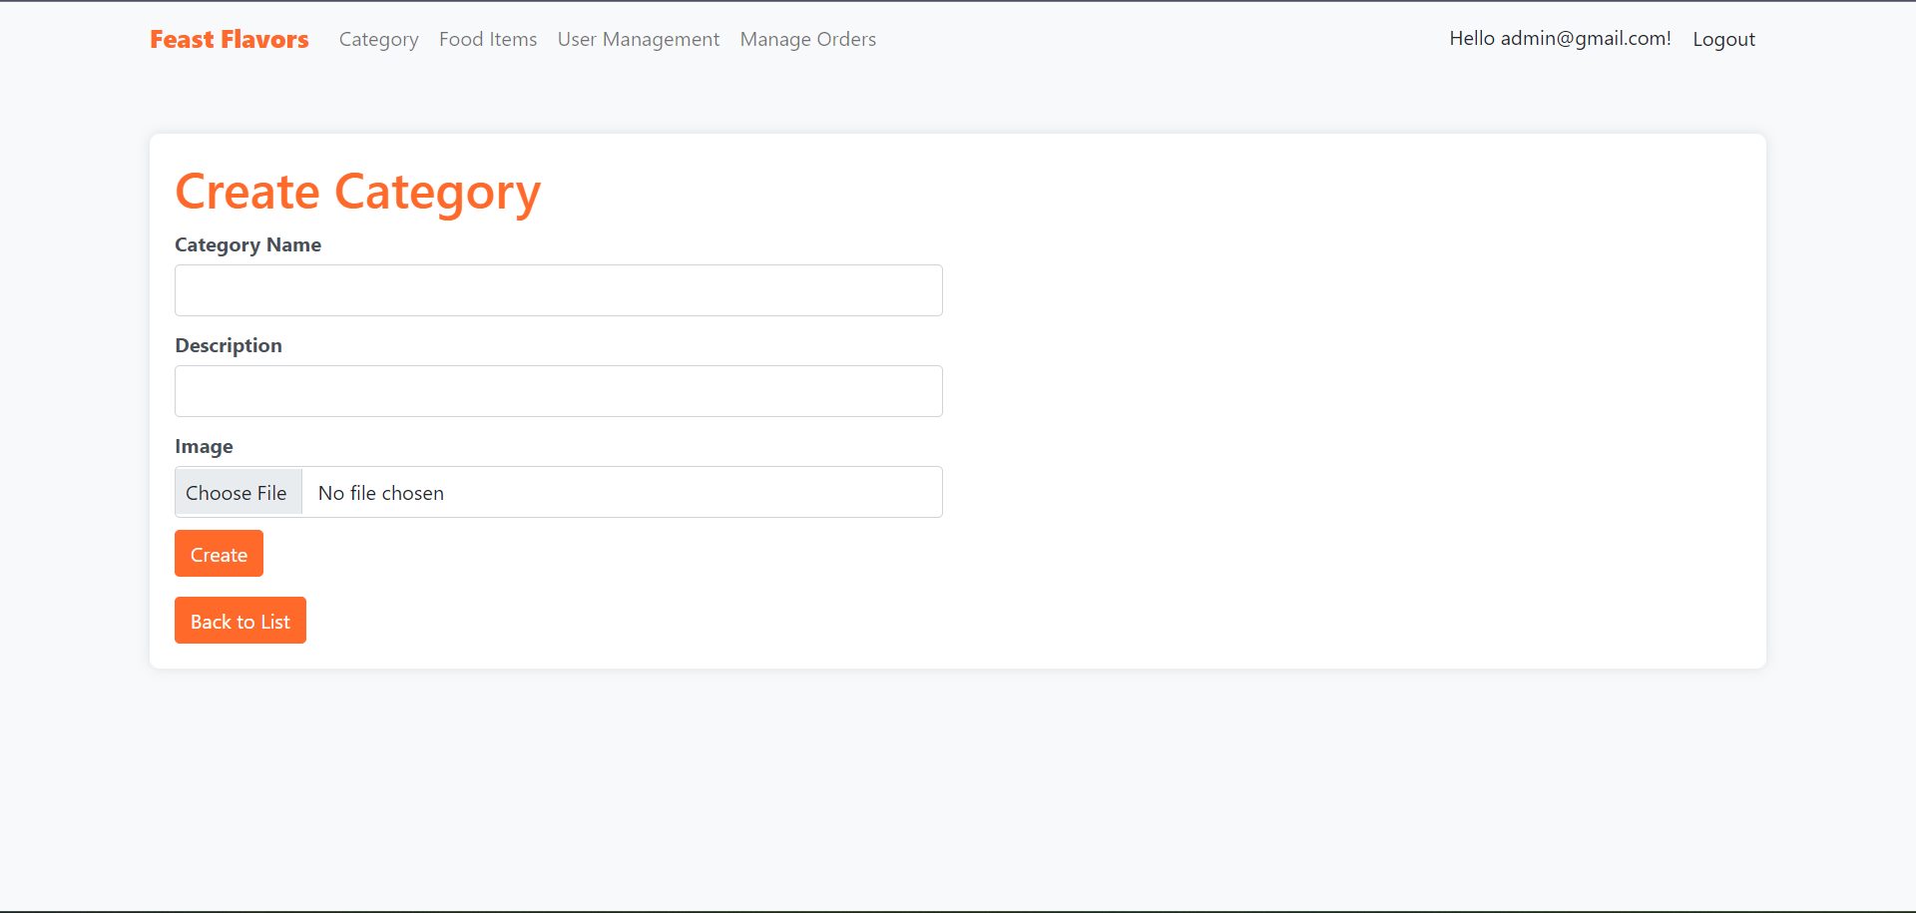

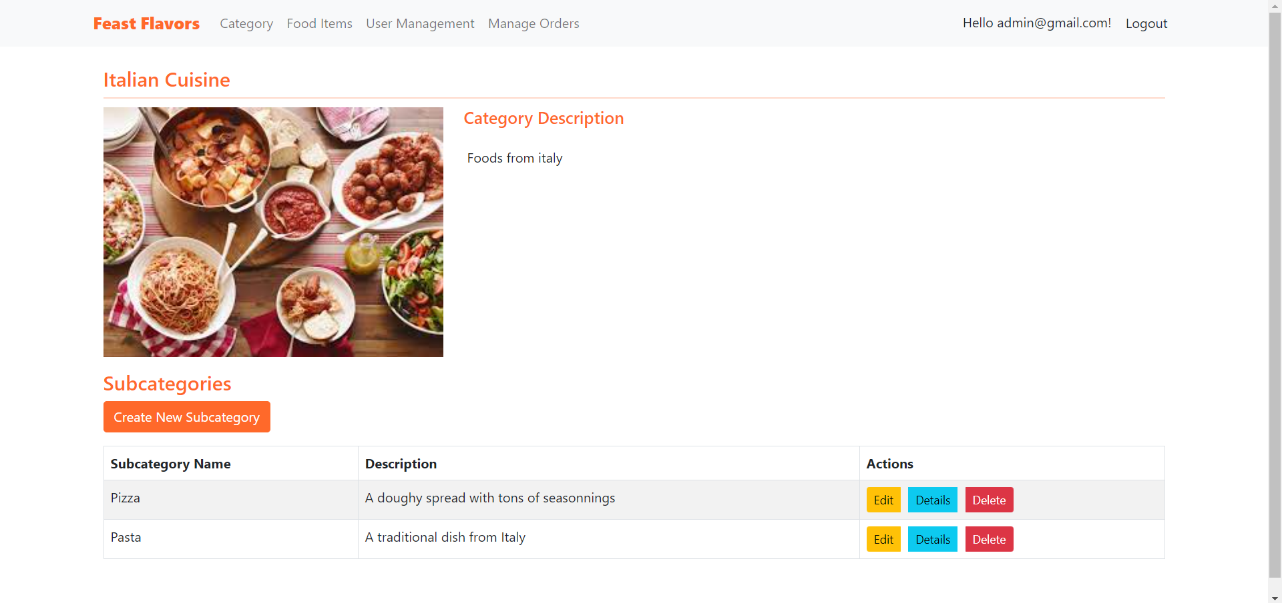

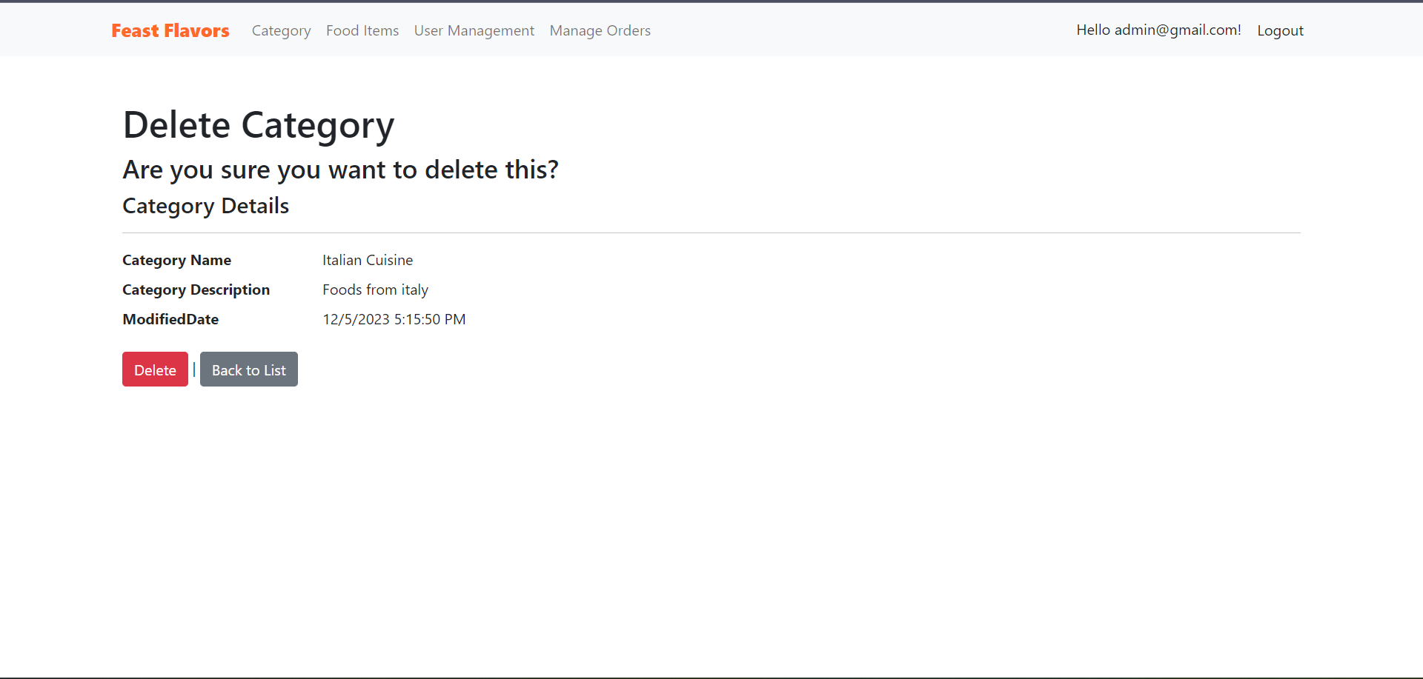

Figure 27: Category Management (CRUD)

These views and interface represents the CRUD functionality of Categories management for Admin where there are different pages in order to create, edit, view and delete categories to the system.

Sub-Categories (CRUD)

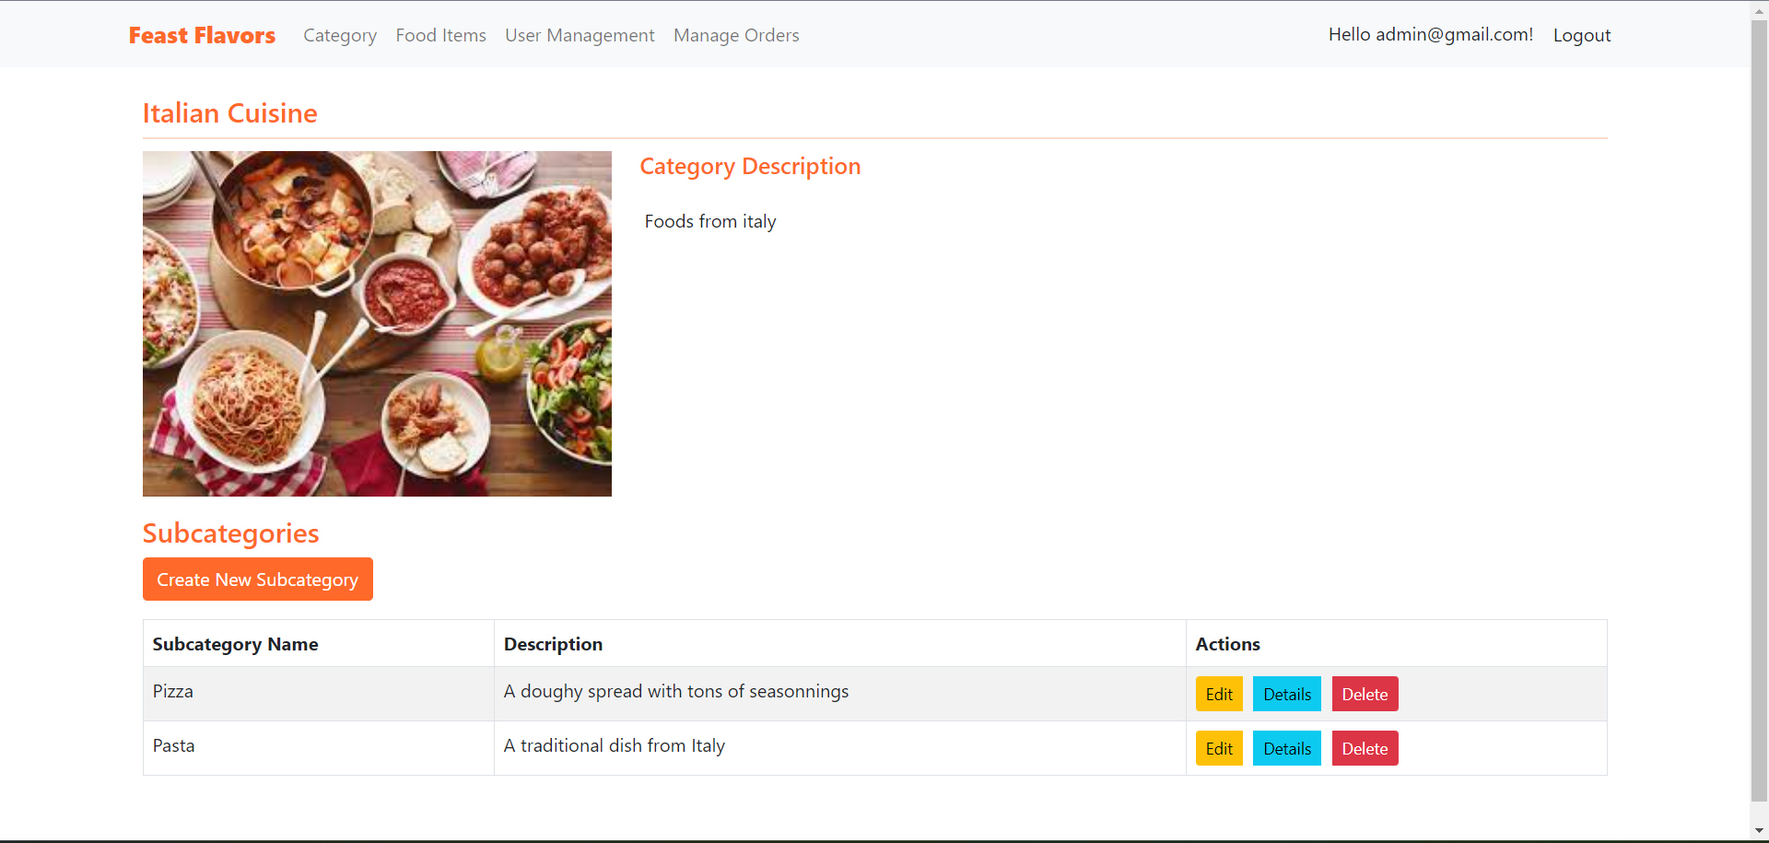 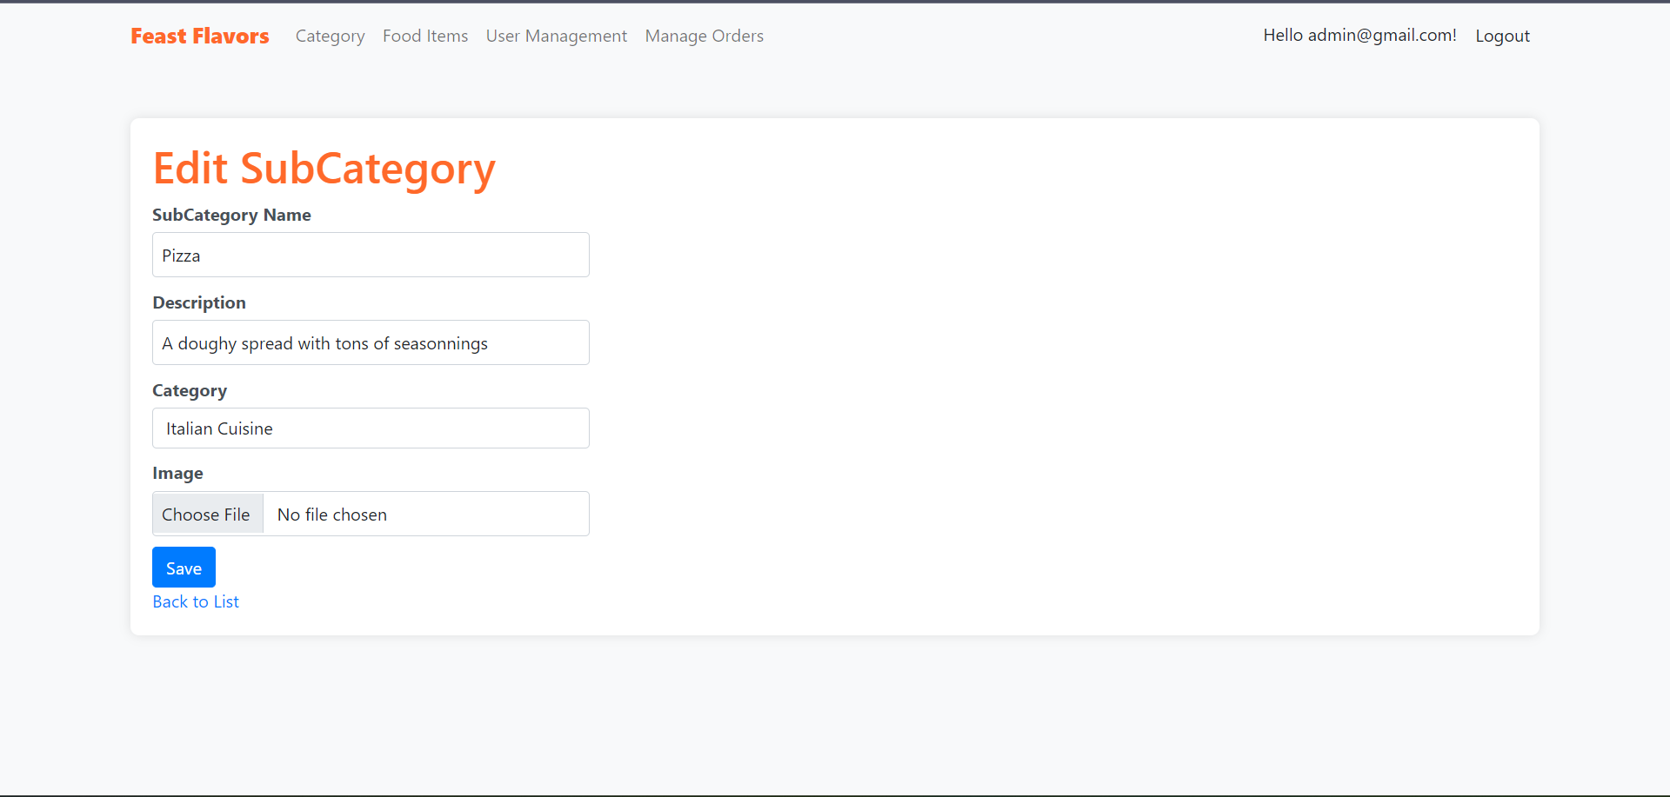 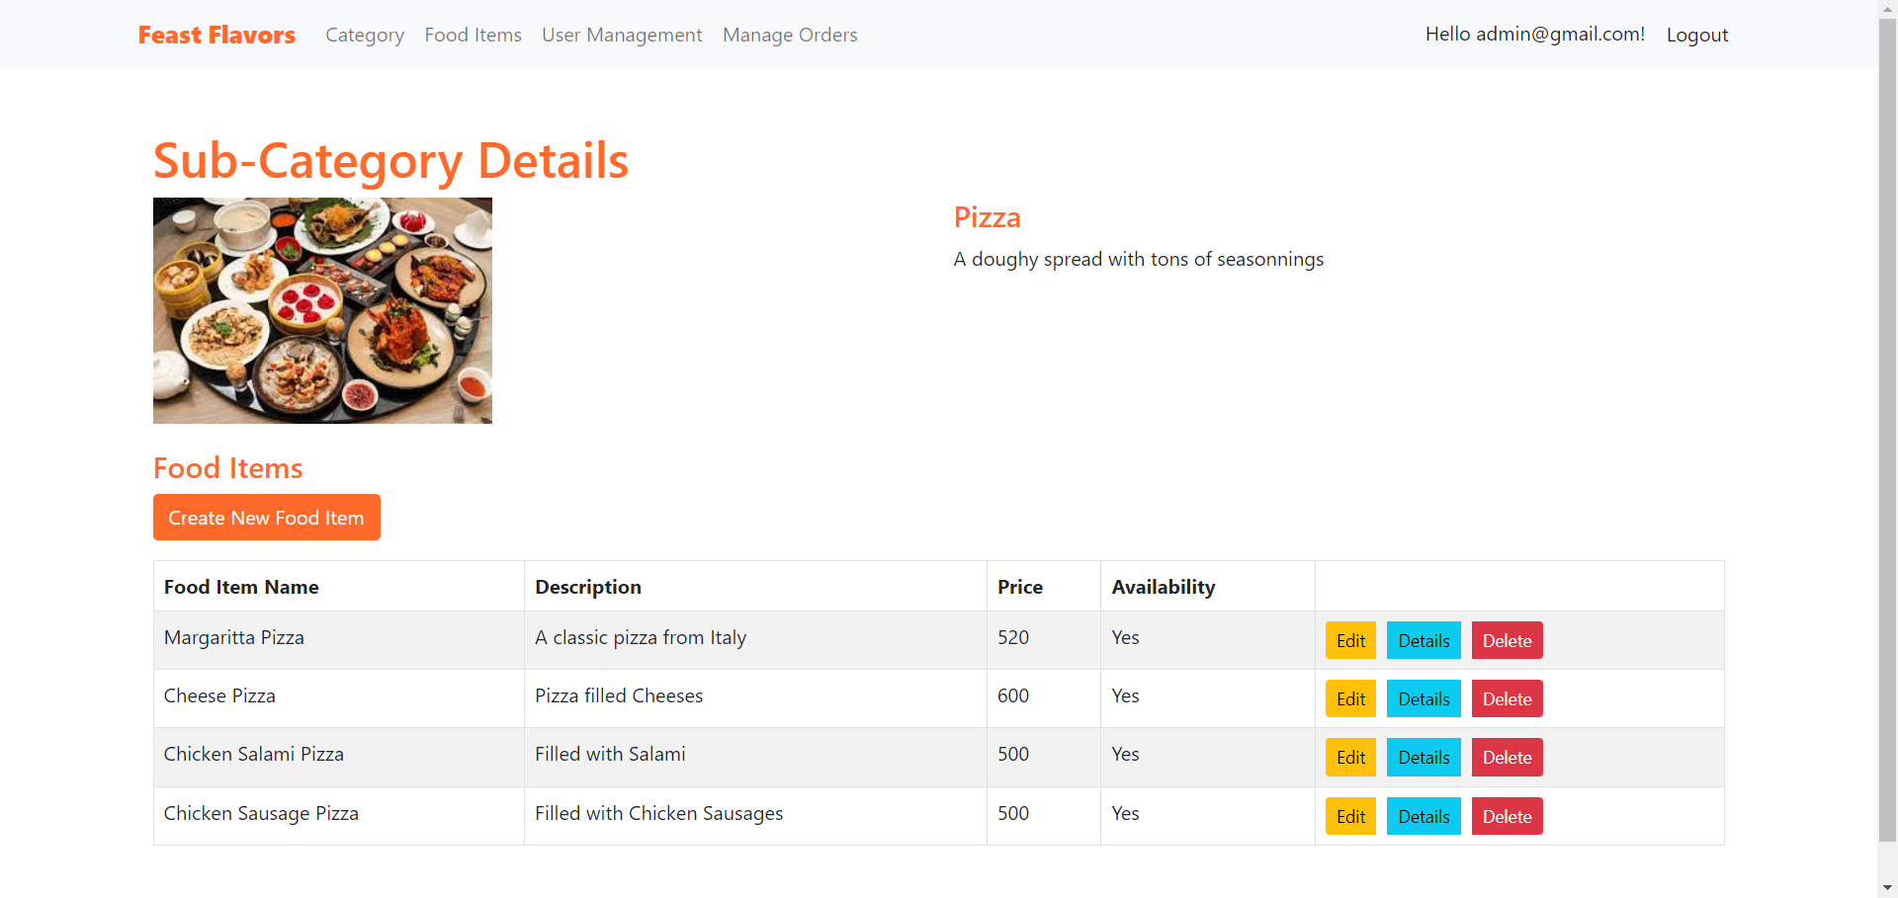 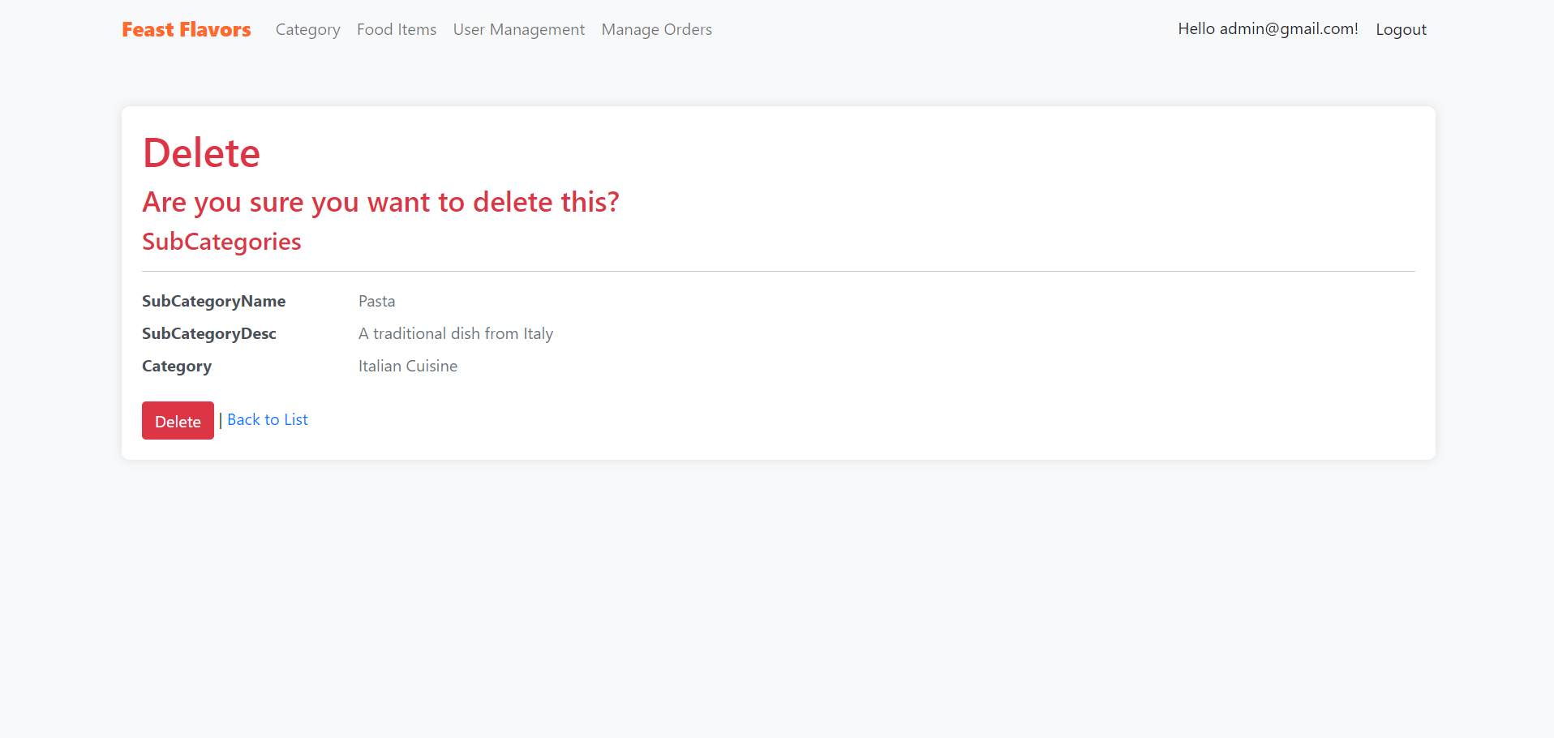

Figure 28: Sub-Categories Management (CRUD)

The above interfaces represents CRUD functionalities that can be performed by admin on Sub-Categories.

Products/Food Items (CRUD)

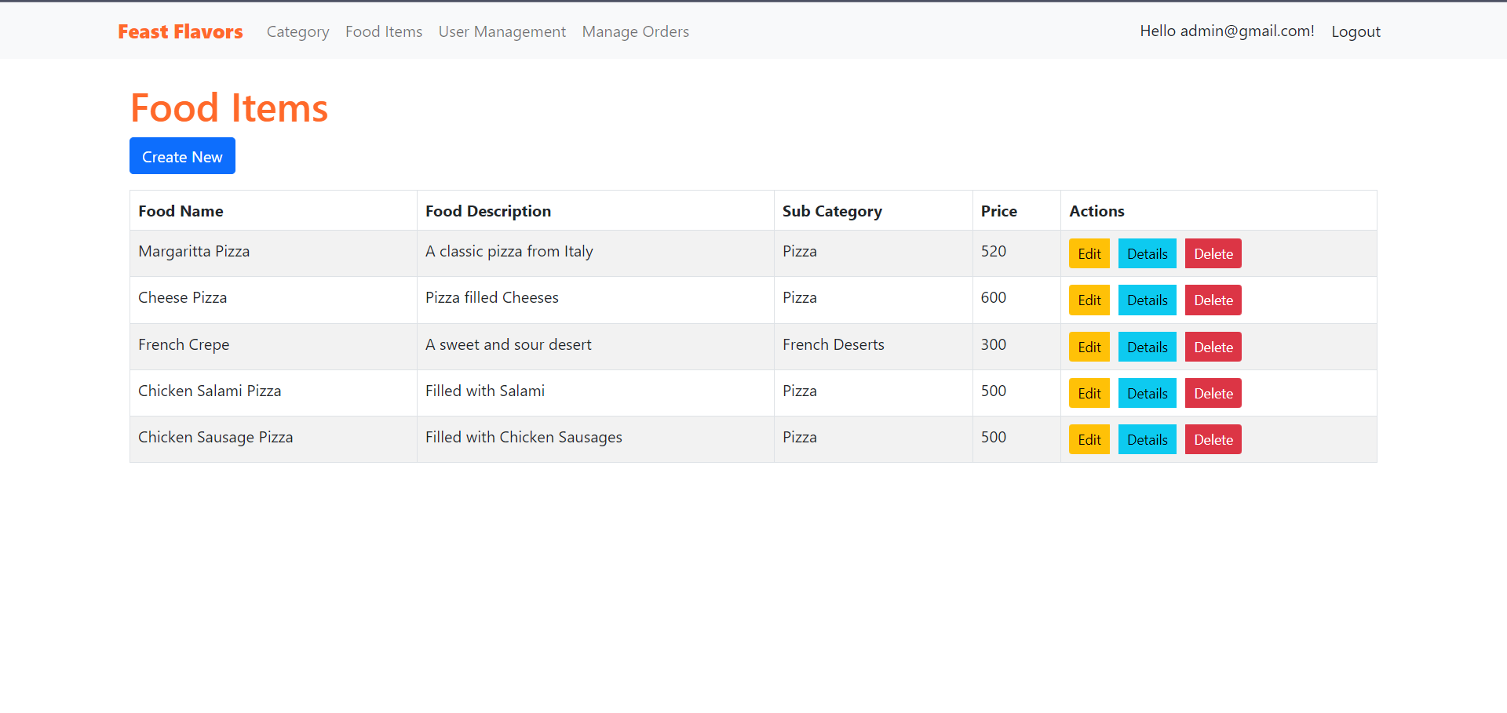 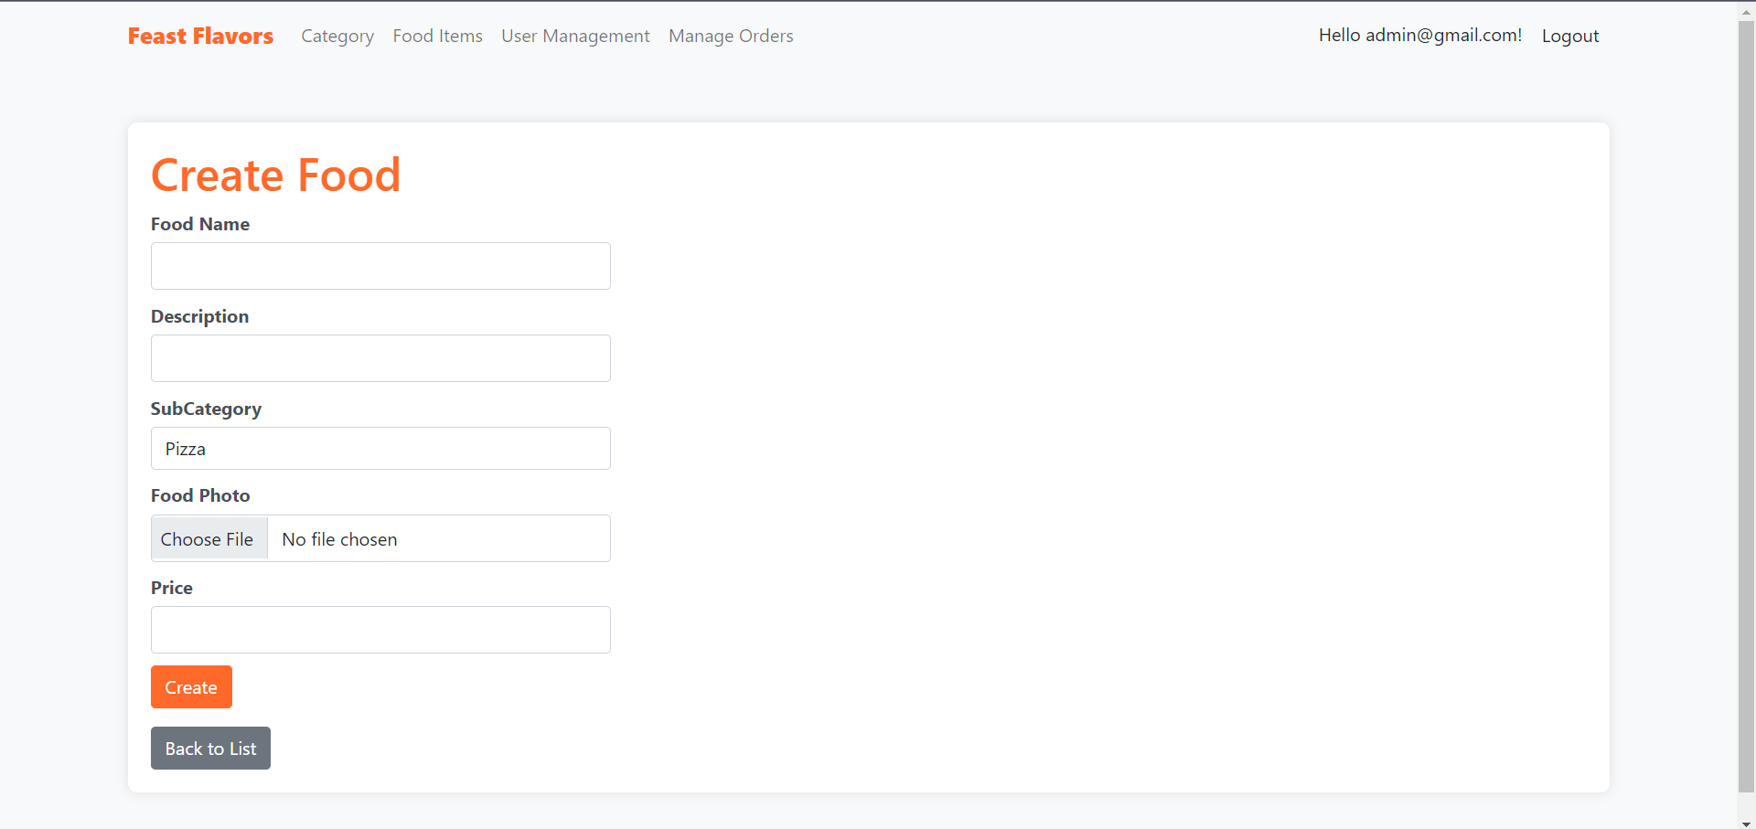 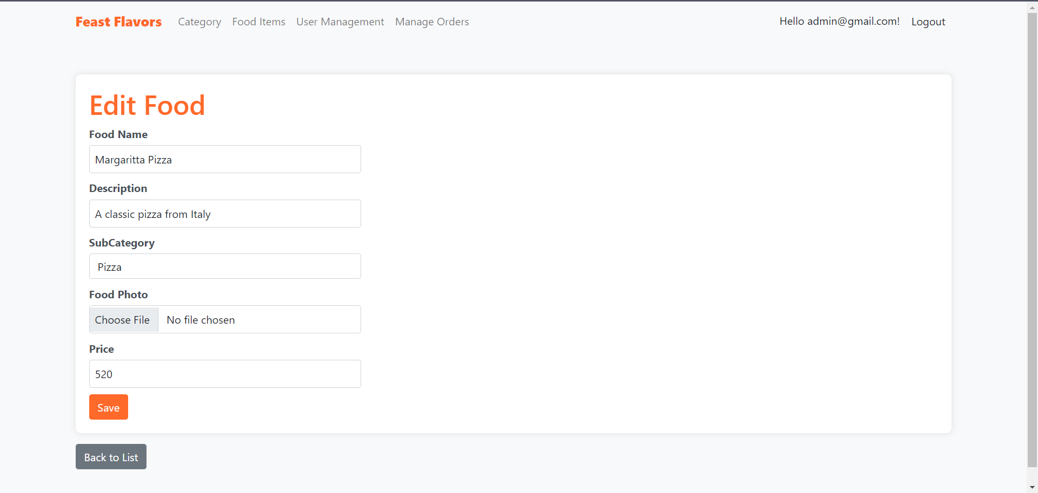 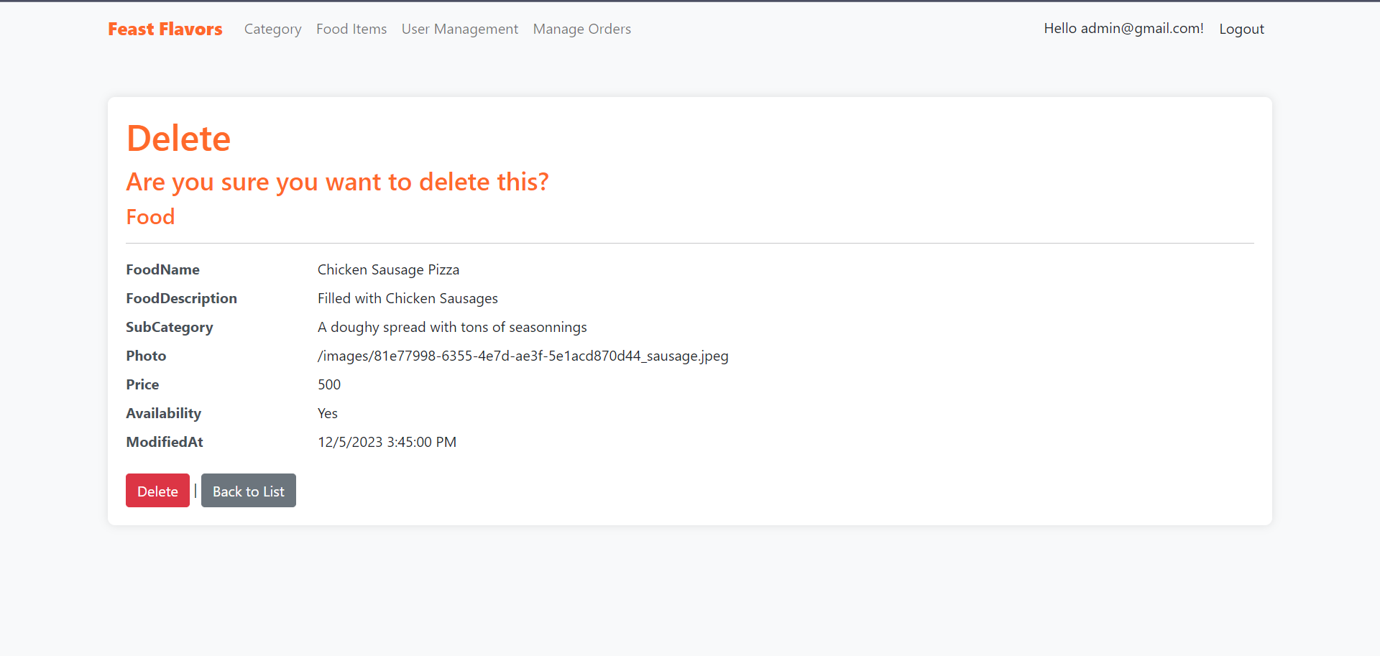

Figure 29: Food Items Management (CRUD)

The above interfaces represents CRUD functionalities that can be performed by admin on Food Items.

User Management (RUD)

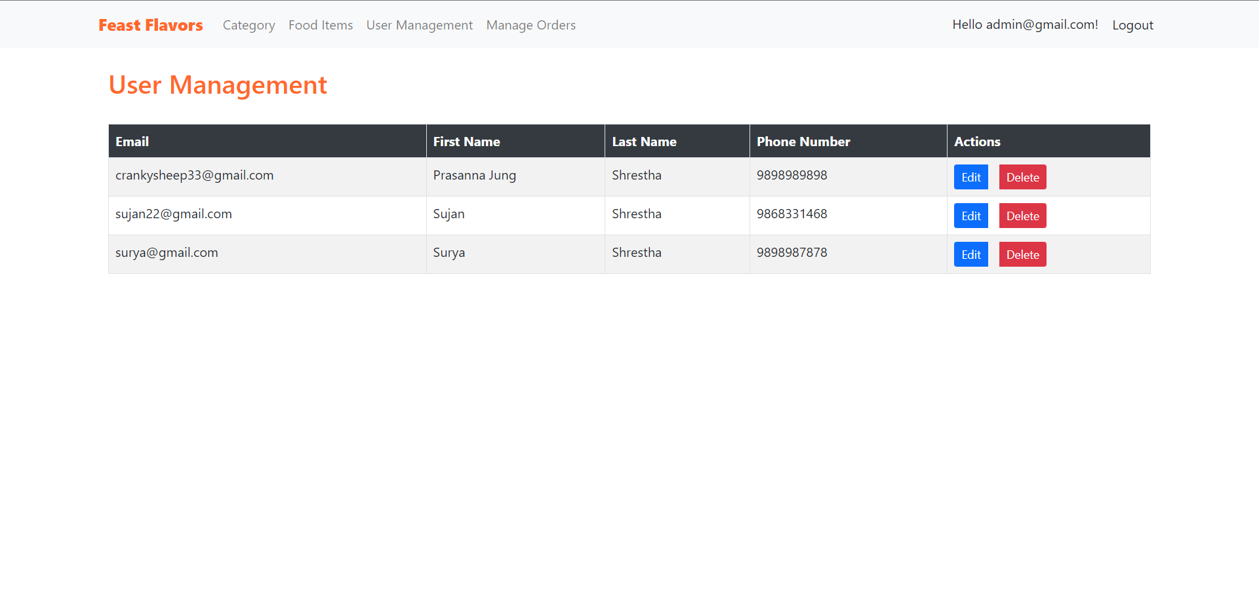 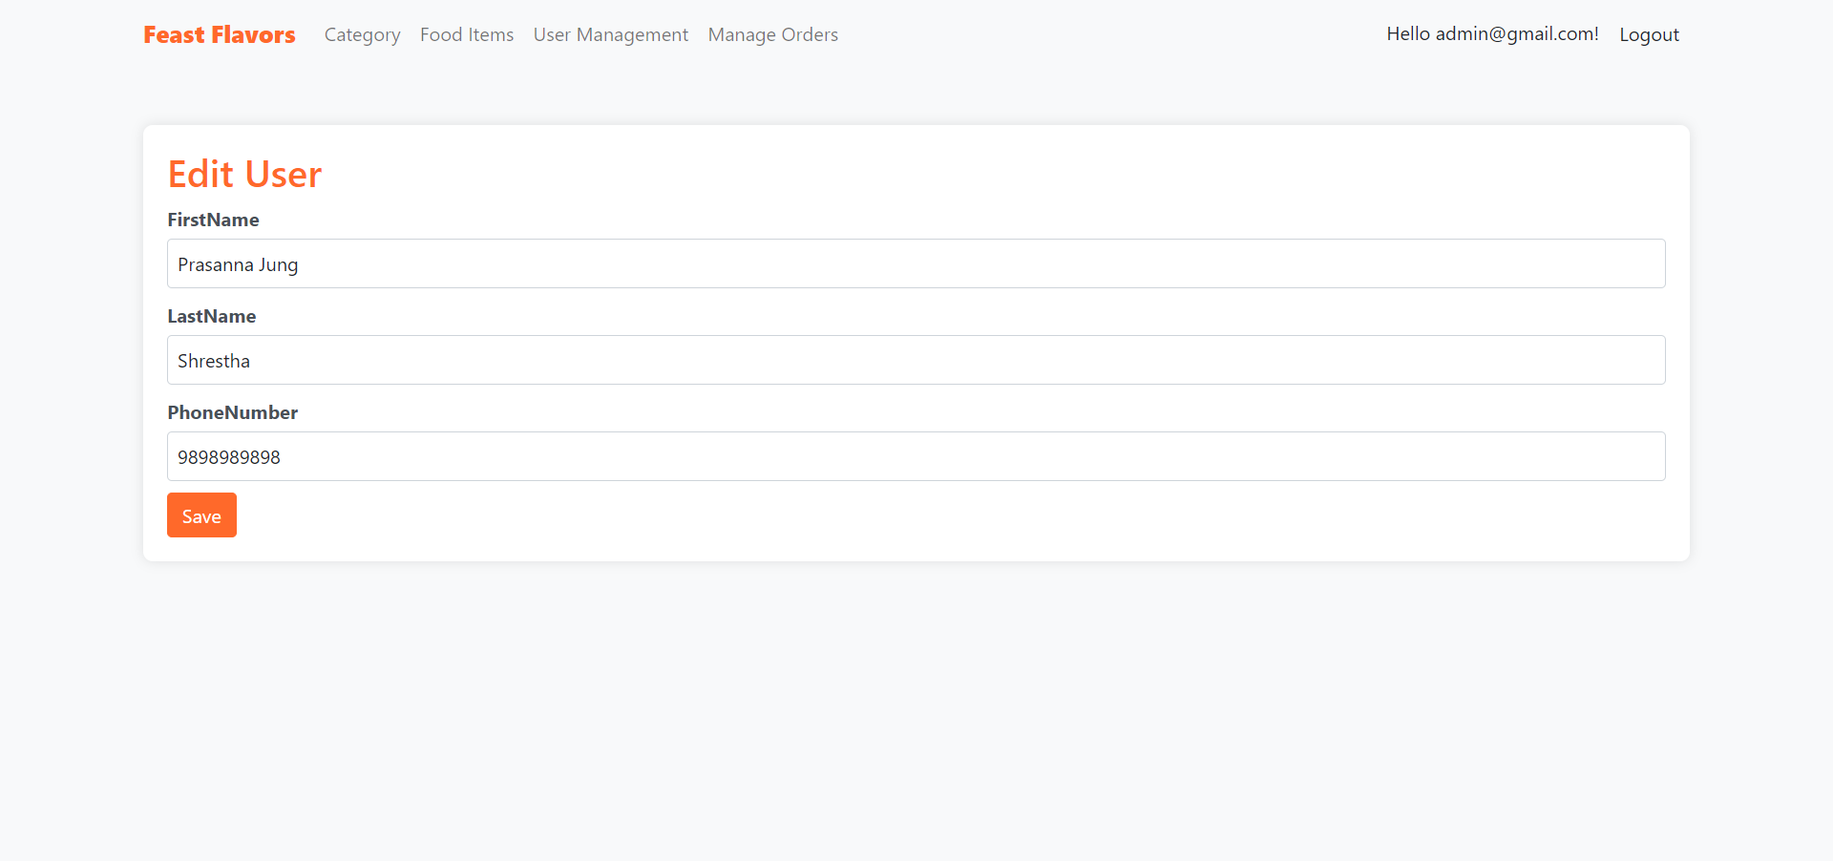 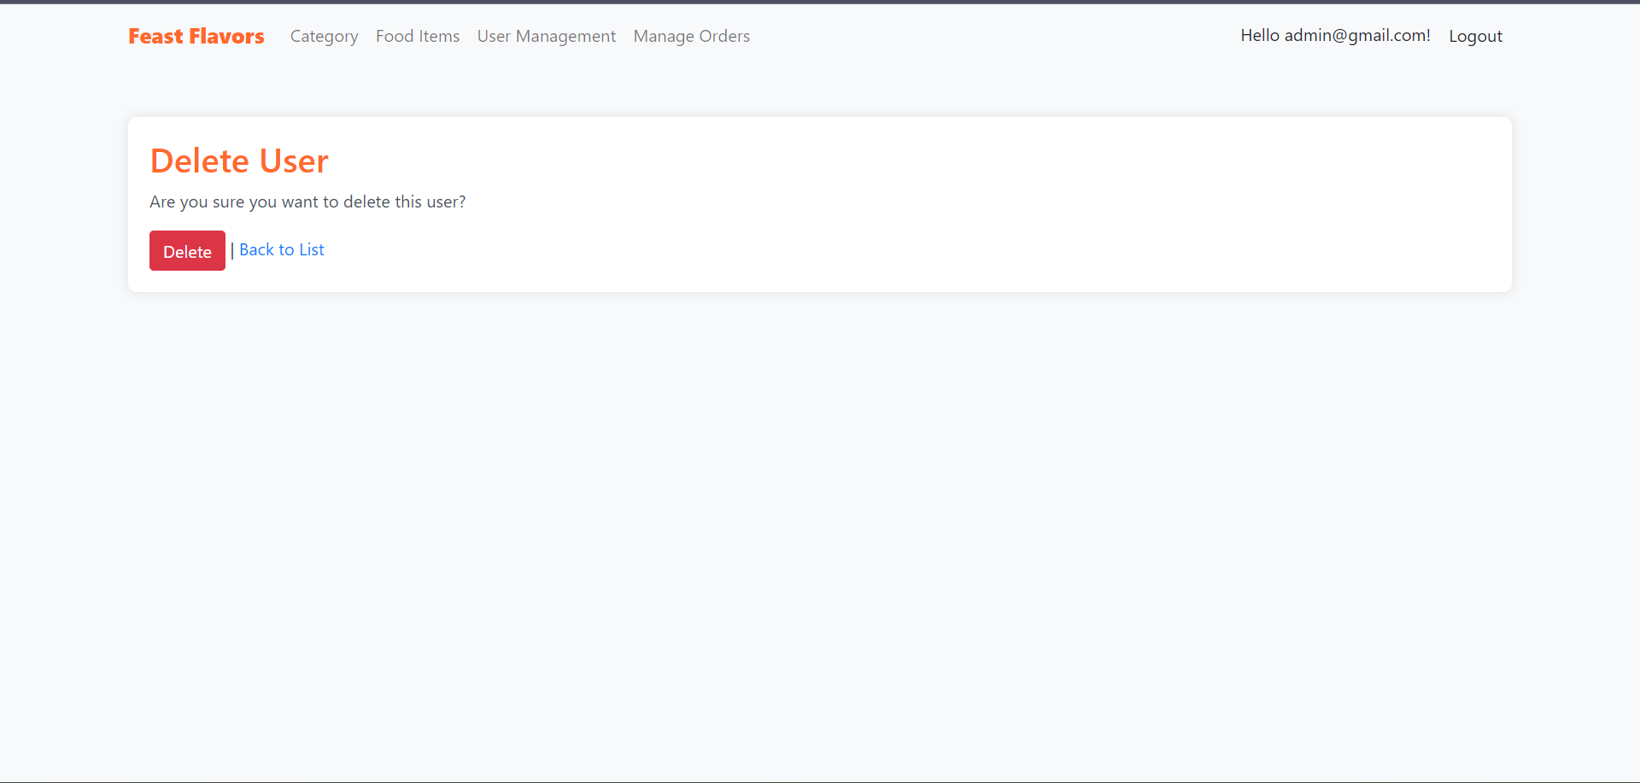

Figure 30: User Management (RUD)

The above interfaces represents RUD functionalities that can be performed by admin on User Management.

Admin Order Management

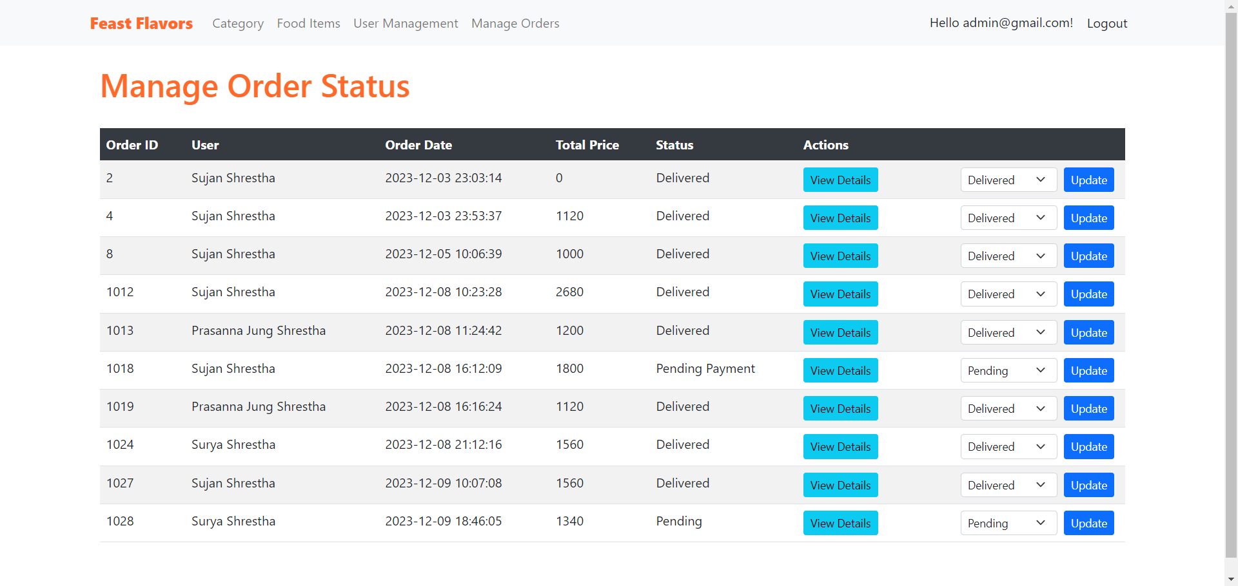

Figure 31: Order Status Management Page

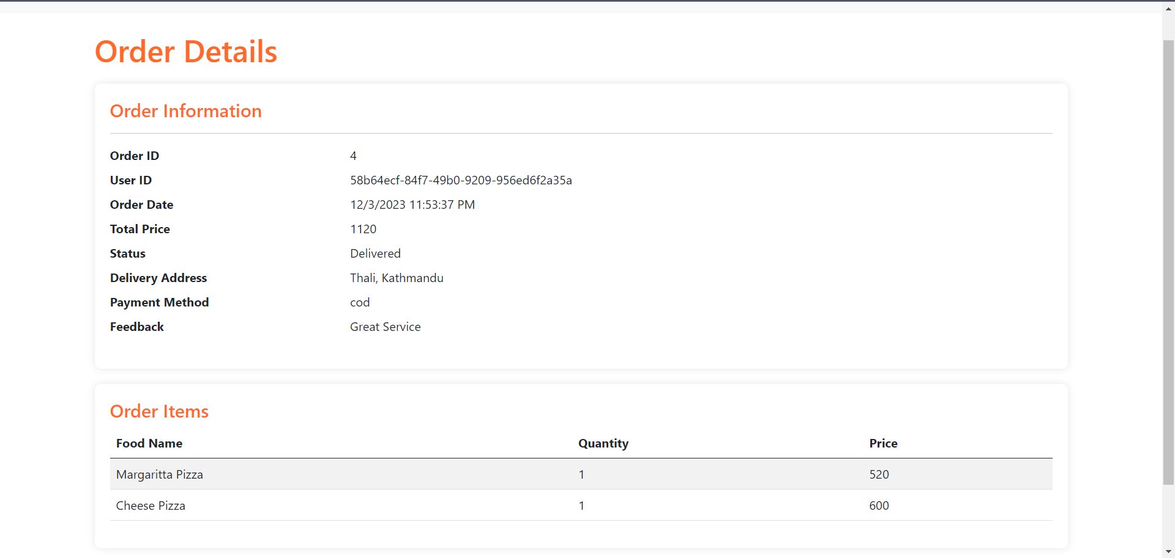

Figure 32: Order Details Page

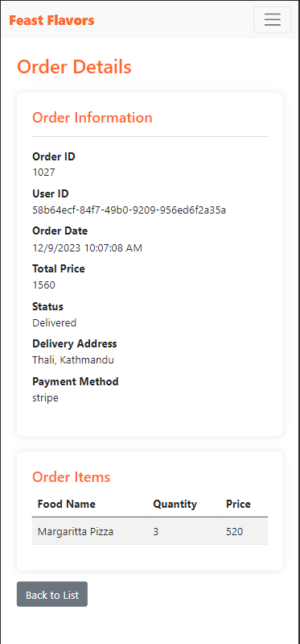

Figure 33: Order Details Page Mobile View

# Implementation

With all the designing process including different techniques such as Entity Relationship Diagram, Use Case Diagram and Database Schema and UI development. We move on towards the actual implementation or development of the project it self.

## Factors related to the Design of the User Interface

User-centric Design:

Design the system on the basis of needs and expectations alogn with analyzation of requirements of the user during the design process.

Responsive Layout

Ensure the adabtability of the user interface remains consistent with changes in the resolution of devices. Implementation of responsive design principles is taken into consideration.

Visual Hierarchy and Clarity:

Provode clear and consistent details to the elements of interface to guide user’s attention and maintain logical flow of information to enhance the readability of the system.

Consistant Design:

A specific color scheme, layout and blueprint is maintained over the system considering the importance of typography and iconography of the system to maintain consistant design (Kim, 2020).

## Factors related to the development and organization of the system for real-world deployment and its implications.

Scalability

The system should be implemented with ability to handle growth in terms of users, data and transactions in future so a selection of scalable technologies and architecture is important.

Security Concerns

A robust security measure should be considered to protect and prevent breach of user data and ensure the integrity of the transaction done in the system.

Data Backup and Recovery

In case of system failure or any other disruptions that can lead to data loss, a reliable mechanism for data recovery and backup should be created.

Performance monitoring and Optimization

In order to identify and address the bottlenecks and optimize resource usage of the system, certain monitoring tools can be used to track system metrics and conditions.

Cross browser and Cross platform compatibility

The system should comply to work with different web browsers and platforms for which a responsive design and test should be carried out on multiple platforms.

## Steps of Implementation of system

Environment Setup

The chosen development environment with necessary tools and frameworks is .NET core with IDE Visual Studio of course. And a Microsoft SQL Server is chosen to handle all the database implementations.

Database Design and Implementation

After the environment setup, a database plan was created to design and implement a database required for the system with the help of above-mentioned designing tools (McLeed, 2011).

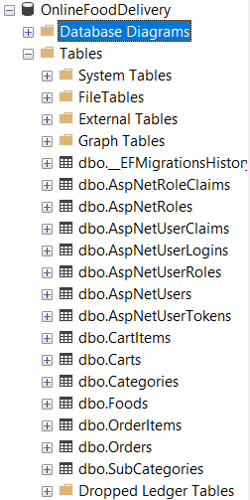

Figure 34: Database Tables

A database will all the necessary table is created for the development of the system.

Backend Development

This phase of the implementation includes development of server-side logic using C# with creation of certain models and mechanisms. Business logic including handling food items, categories, orders and other core functions are implemented in this phase. Here, below some snippets are provided where Model-View-Controller (MVC) architecture is used.

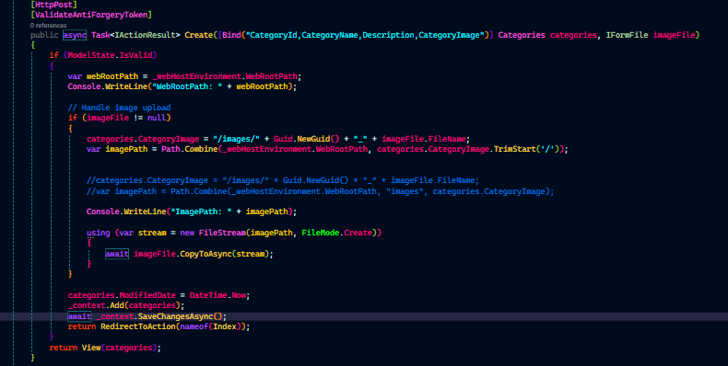 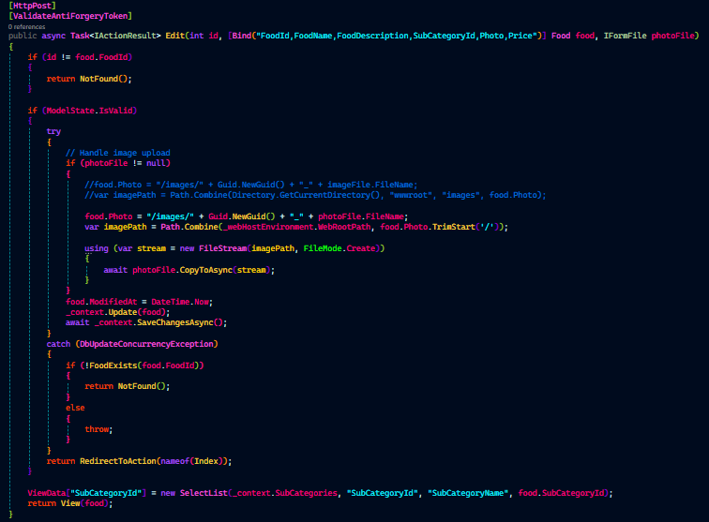 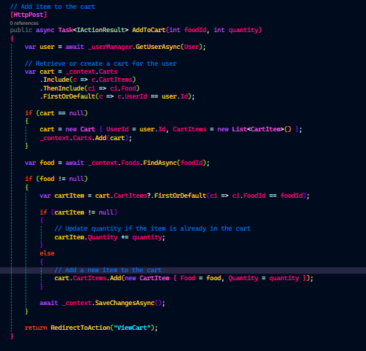 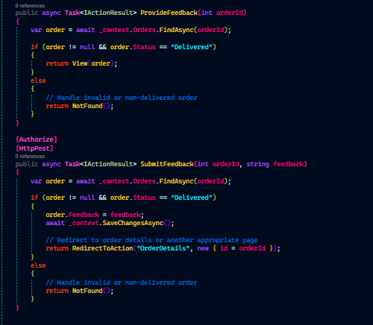

Figure 35: Backend Development Code Snippets

Frontend Development

The user interface of this system is developed through the use of HTML, CSS, JavaScript and Jquery for certain functionalitites. There is also the user of Bootstrap framework of CSS which is used to create responsive views for users across different devices. Some of the code snippets are provided below:

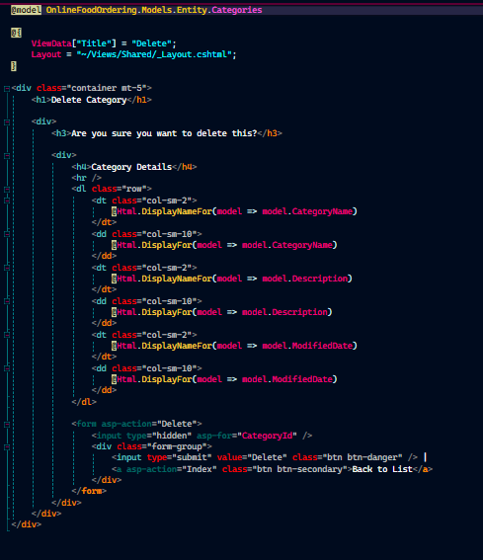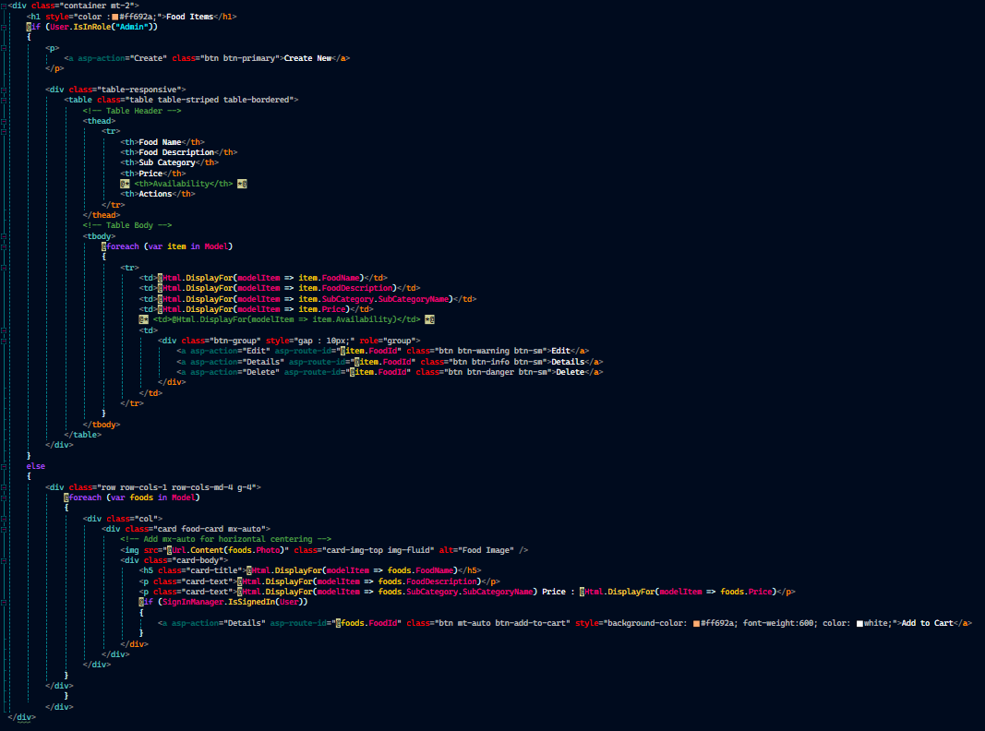

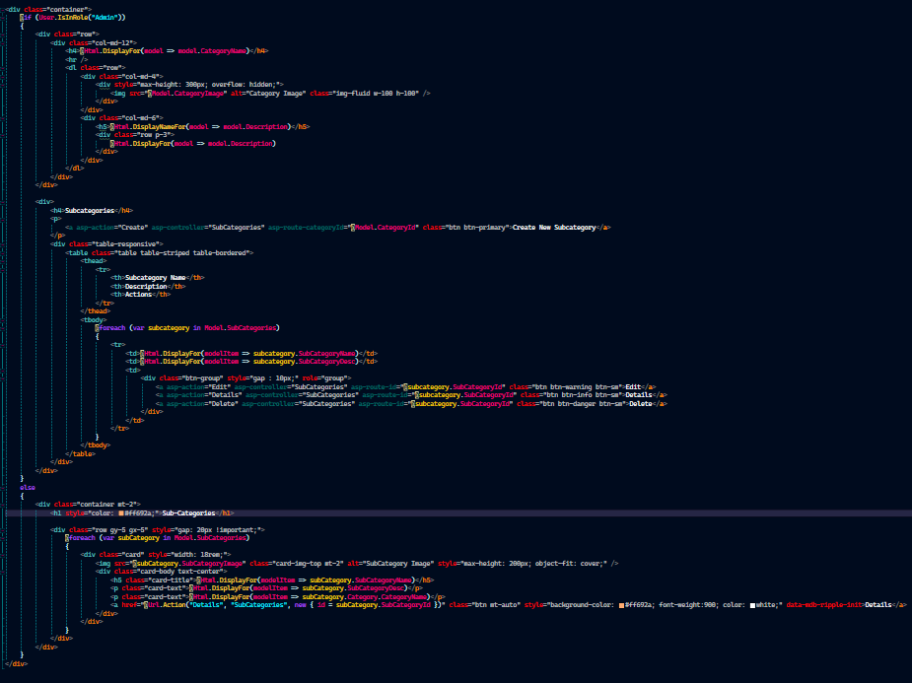

Figure 36: Front-end Development Code Snippets

User Authentication and Authorization

For the implementation of the Authentication and authorization, the identity extension of the .NET environment is used. The roles among the normal user and admin user is alse setup with Identity package. From sign in to the log in every mechanism is implemented using identity package.

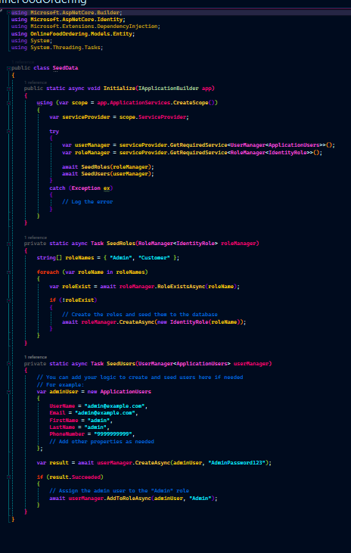 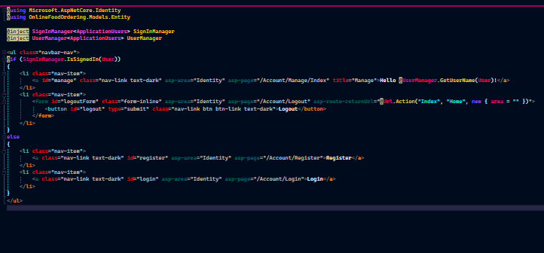

Figure 37: Identity Authentication and Authorization Code snippets

Payment Integration (Stripe)

An ecternal online payment mechanism is used in the system named Stripe which allows users to pay via their credit card and place the order in the application. For this API integration is done with Strpe secret key and use of Stripe.Net extension. Here are the code snippets of this implementation:

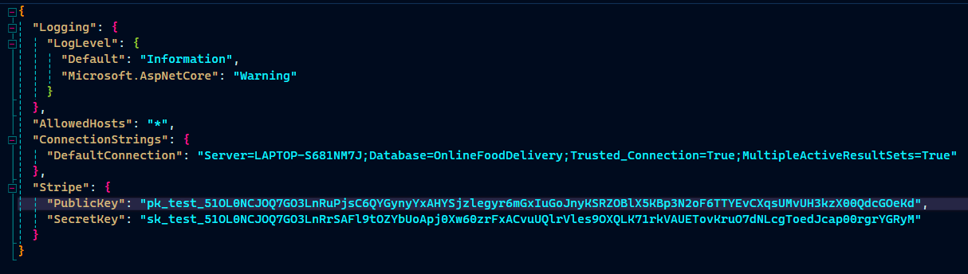  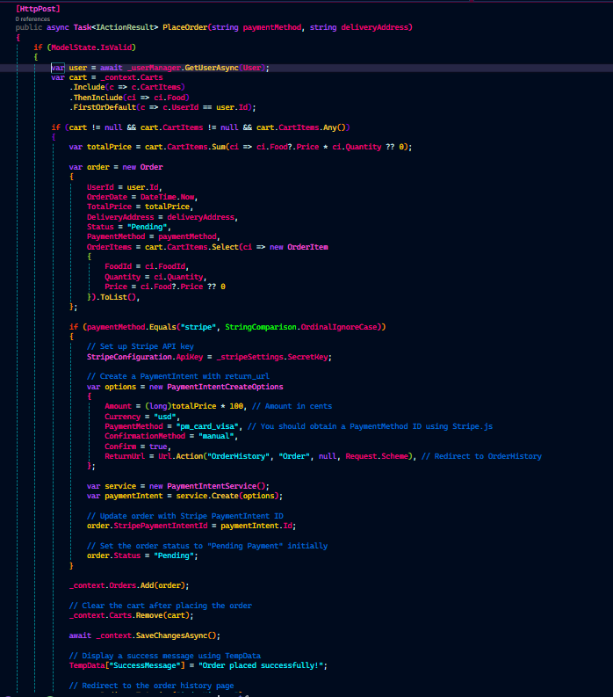

Figure 38: Stripe Payment Integration Code Snippets

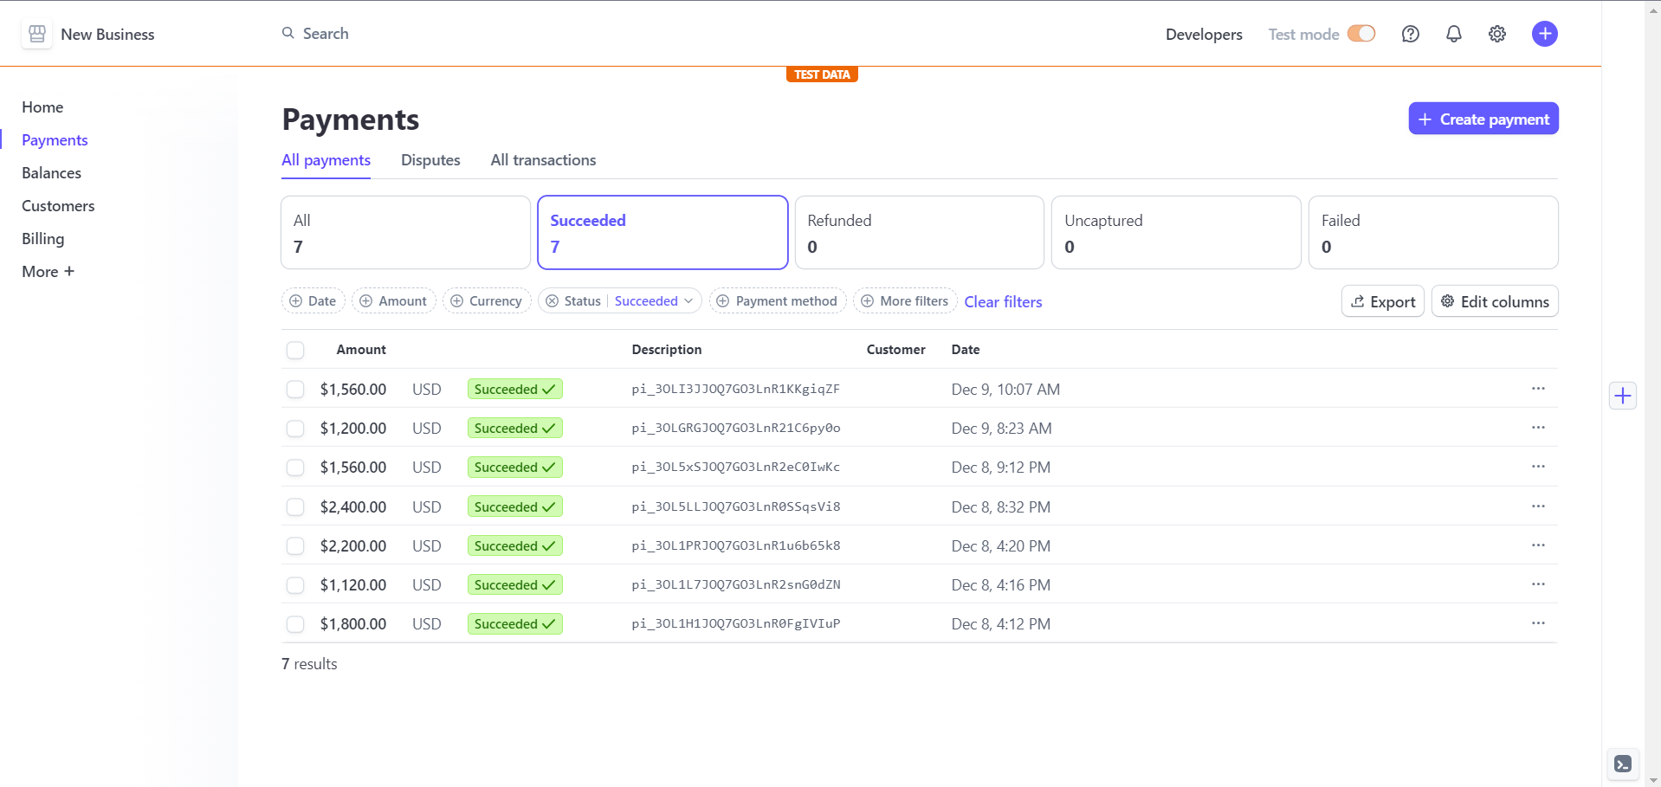

Figure 39: Stripe Dashboard View

# Conclusion

In conclusion, Feast Flavors, a online food delivery platform successfully implements a user friendly interface along with robust functionalities. The project has achieved and met all the requirements and goals by creation of intuitive interface, secure backend process implementation and considerations of different factors of designing, development, and deployment. This online food delivery system depicts a commitment to provide a seamless and efficient experience on both ends of the administration and user.

# References

Cagiltay, N. E. (2013, August 8). Performing and analyzing non-formal inspections of entity relationship diagram. Journal of Systems and Software, 2184-2195. doi:https://www.sciencedirect.com/science/article/abs/pii/S0164121213001015

Cleve, A. (2015). Understanding database schema evolution. Science of Computer Programming. doi:https://doi.org/10.1016/j.scico.2013.11.025

Kim, J. (2020). Designing emotionally evocative homepages. mpirical study of the quantitative relations between design factors and emotional dimensions. doi:https://doi.org/10.1016/j.ijhcs.2003.06.002

McLeed, L. (2011, October 18). Factors that affect software systems development project outcomes. 1–56. doi:https://doi.org/10.1145/1978802.1978803

Parker. (2009). Use case diagrams in support of use case modeling. Journal of Database Management, 1-24. Retrieved December 8, 2023, from https://circle.visual-paradigm.com/docs/uml-and-sysml/use-case-diagram/

Wiley, J. (2012). System Design and Practice. Retrieved December 8, 2023, from https://books.google.com.np/books?hl=en&lr=&id=w8k3aXBnDP4C&oi=fnd&pg=PP8&dq=system+design&ots=M5Fi33zQd1&sig=nnZRXSomeLPMj5Un4DW993UdEao&redir_esc=y#v=onepage&q=system%20design&f=false

# Appendices

## User Manual

